

Faculty of Information Technology

***Computer Science Department***

***Artificial Intelligence***

Mobile Skin Condition Diagnosis Using Neural Networks

Graduation Project (2) Report

Prepared by:

|  |  |
| --- | --- |
| **Students Name** | **Student ID** |
| **Hasan Al-Zubaidi** | **202010045** |
| **Yara Al-Thahabi** | **201910717** |
| **Obada Muqbel** | **202010367** |
|  |  |

Supervised by:

Laith W. Al Shehab

**To obtain**

**BSc in Artificial Intelligence**

2 / 2024

Group No.: AI-2-2-5

Copyright © 2023-2024 - All rights reserved.

Middle East University

|  |
| --- |
| Declaration **إقرار الملكية** |
| Declaration  We hereby acknowledge that the work presented in this document report and the ideas based upon are the group members own unless stated otherwise and properly cited in text and referenced at the end of the document.   |  |  |  |  | | --- | --- | --- | --- | | Date | Signature | Students Name | Student ID | |  |  | Hasan Al-Zubaidi | 202010045 | |  |  | Yara Al-Thahabi | 201910717 | |  |  | Obada Muqbel | 202010367 | |  |  |  |  | |
|  |

|  |
| --- |
| Supervisor Approval **موافقة المشرف** |
| **APPROVAL FOR SUBMISSION**  I certify that this project report entitled “**MOBILE SKIN CONDITION DIAGNOSIS USING NEURAL NETWORKS**” was prepared by **………** has met the required standard for submission in partial fulfillment of the requirements for the degree of Bachelor of Science in Artificial Intelligence at MEU.  Approved by  Signature: ……...……..………………………..................  Supervisor: Dr…..…….…………………………………  Date: ……………..……………………………………… |
|  |

Table of Contents

Declaration 2

Supervisor Approval 3

Acknowledgement 5

Abstract (English) 6

Abstract (Arabic) 7

List of Figures 8

List of Abbreviations 9

List of Abbreviations 10

**Chapter 1: Introduction** 11

**Chapter 2: Background** 15

**Chapter 3 – Literature Review** 20

**Chapter 4 – Dataset** 23

**Chapter 5 – Methodology** 28

**Chapter 6 – Results** 36

**Chapter 7 – Discussion** 44

**Chapter 8 – Conclusion** 46

**REFERENCES** 47

**APPENDICES** 51

|  |
| --- |
| Acknowledgement **صفحة الشكر والعرفان** |
| **ACKNOWLEDGEMENT**  I would like to thank everyone who had contributed to the successful completion of this project starting from the guidance of our supervisor Dr. Laith W. Shehab and the teamwork with my colleagues who worked with this project Dr. ………., Mrs/Miss………. |
|  |

|  |
| --- |
| Abstract (English) **المستخلص (إنجليزي)** |
| **Title**  Mobile Skin Condition Diagnosis Using Neural Networks  **ABSTRACT**  This project introduces a user-friendly approach to skin health assessments by employing Convolutional Neural Networks (CNNs). With the power of your mobile phone, this system offers a convenient and accessible means for users to gain insights into their skin conditions. The application provides not only rapid analysis but also valuable information about the observed skin conditions and potential steps to treat it.  Our project addresses limited access to dermatological care and high costs of traditional diagnosis. Many people, especially in remote areas, can't see dermatologists, leading to delayed or incorrect diagnoses. This can worsen skin conditions and raise healthcare costs. Our solution aims to provide an efficient and accessible way to diagnose skin disease.  Recognizing the widespread impact of diseases worldwide, we have developed An AI application using CNN models (VGG-19, DenseNet, ResNet) via a Django API for rapid and accurate skin disease diagnosis. Designed to improve dermatological care accessibility, especially in remote areas, DermaTech aims to reduce healthcare costs and enhance patient outcomes by enabling remote consultations and timely interventions. This innovation holds promise for advancing public health through enhanced diagnostic capabilities and equitable healthcare access. |
|  |

|  |
| --- |
| Abstract (Arabic) **المستخلص (عربى)** |
| **عنوان المشروع**  تقييم صحة البشرة بإستخدام الشبكات العصبونية على الهاتف المحمول  **المستخلص**  يُقدم هذا المشروع نهجًا وديًا لتقييم صحة البشرة باستخدام الشبكات العصبونية التابعة للتحويل (CNNs). من خلال هاتفك المحمول، يُوفر هذا النظام وسيلة مريحة وسهلة الوصول للمستخدمين للحصول على رؤى حول حالتهم الجلدية. توفر التطبيق لا يقدم فقط تحليلاً سريعًا ولكن أيضًا معلومات قيمة حول حالة البشرة الملاحظة والخطوات المحتملة لعلاجها.  يعالج مشروعنا الوصول المحدود إلى الرعاية الجلدية والتكاليف المرتفعة للتشخيص التقليدي. لا يستطيع العديد من الأشخاص، خاصة في المناطق النائية، رؤية أطباء الأمراض الجلدية، مما يؤدي إلى تشخيص متأخر أو غير صحيح. وهذا يمكن أن يؤدي إلى تفاقم الأمراض الجلدية ورفع تكاليف الرعاية الصحية. يهدف حلنا إلى توفير طريقة فعالة ويمكن الوصول إليها لتشخيص الأمراض الجلدية.  التطبيق يعتمد على الذكاء الاصطناعي باستخدام نماذج CNN المتقدمة (VGG-19 وDenseNet وResNet) عبر واجهة برمجة تطبيقات Django لتشخيص سريع ودقيق للأمراض الجلدية. تم تصميمه لتحسين إمكانية الوصول إلى رعاية الأمراض الجلدية، خاصة في المناطق النائية، وتهدف إلى تقليل تكاليف الرعاية الصحية وتعزيز نتائج المرضى من خلال تمكين الاستشارات عن بعد والتدخلات في الوقت المناسب. ويبشر هذا الابتكار بالنهوض بالصحة العامة من خلال تعزيز القدرات التشخيصية والوصول العادل إلى الرعاية الصحية. |
|  |

|  |
| --- |
| **LIST OF FIGURES**  **#-FIGURE TITLE PAGE**  1-Device used for skin assessment 14  2-Dermnet dataset samples 23  3-Dermnet dataset – Train Distribution 24  4-Dermnet dataset – Test Distribution 24  5-Bug bite dataset samples 25  6-Bug bite dataset – Train Distribution 25  7-Bug bite dataset – Test Distribution 25  8-Dermatech 1.0 dataset – Train and Test Distribution 26  9-Dermatech 2.0 dataset – Train and Test Distribution 27  10-Dermatech 3.0 dataset – Train and Test Distribution 27  11-VGG-19 Architechture 31  12-ResNet Architechture 32  13-DenseNet Architechture 32  14-Model Fit: Underfitting vs. Overfitting (Amazon AWS) 33  15-Dermatech Application Interface 34  16-Dermatech Application Architecture 35  17-DenseNet-201 Classification Report 1.0 36  18-DenseNet-201 Confusion Matrix 1.0 36  19-DenseNet-201 Classification Report 2.0 37  20-Normalized DenseNet-201 Confusion Matrix 2.0 37  21-ResNet-152 Classification Report 2.0 38  22-Normalized ResNet-152 Confusion Matrix 2.0 38  23-VGG-19 Classification Report 2.0 39  24-Normalized VGG-19 Confusion Matrix 2.0 39  25-DenseNet-201 Classification Report 3.0 40  26-Normalized DenseNet-201 Confusion Matrix 3.0 40  27-ResNet-152 Classification Report 3.0 41  28-Normalized ResNet-152 Confusion Matrix 3.0 41  29-VGG-19 Classification Report 3.0 42  30-Normalized VGG-19 Confusion Matrix 3.0 42  31-Models Metrics Comparison 2.0 44  32-Models Metrics Comparison 3.0 45 |

|  |
| --- |
| List of Abbreviations **قائمة الاختصارات** |
| **LIST OF SYMBOLS/ABBREVIATIONS**   * AI Artificial Intelligence * CNN Convolutional Neural Networks * ANN Artificial Neural Networks * ML Machine Learning * DL Deep Learning * VGG Visual Geometry Group * CUDA Compute Unified Device Architecture * GPU Graphics Processing Unit * TL Transfer Learning |
|  |

|  |
| --- |
| List of Abbreviations **قائمة الاختصارات** |
| **LIST OF KEYWORDS** |
|  |

# **Chapter 1: Introduction**

* 1. **Problem Statement and Purpose**

Skin diseases are a significant global health issue in that they affect millions of people across the world. The point of timely and accurate diagnosis for skin diseases is so that they may be effectively treated and managed. However, many individuals lack access to dermatological expertise particularly in remote or underdeveloped areas. Even in places where there is good infrastructure for healthcare provision such as well-equipped hospitals with qualified doctors; dermatologists still face challenges like having too many patients who need their services at once among others being able tell apart visually similar conditions. Consequently, this leads to delayed or wrong diagnoses which result in prolonged suffering, high costs of medical care and in some cases, diseases may reach advanced stages which are hardly treatable. Therefore, there’s need for an easy, reliable method that can reach everyone regardless of their location and at any time to help diagnose skin diseases since this will not only build capacity among health workers but also save more lives. (Kong et al., 2024)

This application seeks to exploit Convolutional Neural Networks (CNNs) combined with state-of-the-art API technology stack to come up with a powerful tool for early and correct diagnosis of skin diseases. Users will be able take photos using their mobile devices then upload them into this application which is trained on CNN models capable of identifying various dermatological conditions. The model instantly tells which specific disease it is.

This application is set out in the following objectives: (Ersavas, Smith and Mattick, 2024)

1. **Make Dermatological Services Reach More People:** By creating something that operates anywhere there is internet connection through smartphones, apps like this help bring closer individuals living far away from hospitals offering such specialized care, even those found within cities but are underserved because they don’t have enough doctors trained in skin diseases treatment.

2.**Enhance Accurate Identification:** Our goal is to heighten corre­ct identification by shaping the CNN model using dive­rse images of skin ailments. This approach aids in sustaining de­pendable accuracy. It's additionally set to simplify de­rmatologists' tasks by conducting initial assessments for them.

3.**Support for Quick Detection and Management**: Identifying a skin proble­m early improves the odds of managing it. This syste­m helps individuals to quickly notice potential skin issue­s. Fast medical assistance become­s feasible, leading to improve­d health progress.

4**. Helping Health Professionals**: This tool could be handy for gene­ral practitioners and skin doctors. They could employ it for ge­tting a second opinion or even for sorting case­s based on the leve­l of emergency.

5. **Educate**: Apart from telling what the ailment is about, the app should educate the user more on such areas like treatment and preventive measures thus creating awareness towards better health care management through understanding.

* 1. **Project and Design Objectives**

Our goal is to make an app that is user-friendly, People can take photos of skin issues or upload existing ones. The app will then quickly analyze the photos using a special computer program called CNN. This program can recognize different skin conditions from the photos. The app will then tell the user what skin condition they have. We want the app to be secure and give correct results, this can help people get treated early. The CNN program will be connected through an API so many people can use it smoothly. (Agency, 2021)

The application is designed to be simple and easy to use for everyone. Its goal is to have a clean and uncomplicated interface that will give clear instructions on how to sign in or sign up for an account. The system also saves all previous scans in a history page which allows individuals to keep track of their skin’s condition over time. Additionally, the app can take a picture directly by using the camera or upload an image from the gallery for diagnosis purposes and it should also work seamlessly on mobile devices such as smartphones through being interactive enough while giving steady performance. (Agency, 2021)

* 1. **Project Scope**

This model developed in this project will be used to detect common skin diseases or conditions, including but not limited to eczema, psoriasis, acne, skin cancer, bug bites, and various dermatitis conditions. The application will be designed for use on smartphones, making it accessible to a broad audience. (ALKolifi ALEnezi, 2019)

* 1. **Intended Outcomes and Deliverables**
* A robust and well-trained model that can quickly diagnose the image provided by the user, ensuring reliable and precise assessments.
* Create a user-friendly application that makes our model accessible to everyone using their smartphones.
* The model could be implemented as an IOT device in some clinics and ERs.
  1. **Motivations**

This skin disease app was created to make getting help easier. Here are the main reasons:

* *Help More People Get Skin Care*

Some people can't see a skin doctor, like those far away or without doctors nearby.

With this app, anyone can get help for skin issues on their device.

* *Better Disease Detection*

Skin diseases can look alike, so they're hard for doctors to diagnose. This app uses a smart computer system trained on many skin disease pictures to spot diseases accurately.

* *Catch Problems Early*

Catching diseases early is key for better treatment. This app quickly checks skin photos and tells you if there's an issue, so you can get help right away if needed.

* *Help Doctors and Nurses*

Many hospitals have too many sick people and not e­nough doctors and nurses. This app can help check people's skin problems first. Then, doctors can focus on the sickest people who ne­ed their help right away.

* *Use Smart Computer Programs*

The app uses new computer programs that can learn and see pictures well. It uses these programs to check skin problems quickly and correctly, even when many people use it at the same time. (Mieras et al., 2018)

* 1. **Contributions**

Since we will be using CNN model mainly, this model will work well with:

* **Skin Conditions**:

Skin conditions can really impact your life, both physically and emotionally. Things like acne, eczema, and psoriasis can be painful and embarrassing, making it hard to do everyday stuff and lowering your quality of life. If you don't treat some skin problems, they can get worse and even lead to serious complications. (GOEL and Hall, n.d.)

For instance, infections like cellulitis can spread quickly if not taken care of and skin cancer, like melanoma, can spread to other parts of your body if you don't catch it early.

Having a skin condition can mess with your head too, it can make you feel down, anxious, or not good about yourself, especially if it's something people can see, like acne or vitiligo.

Sometimes, changes in your skin can even signal something else going on inside your body. So, catching those changes early can help you and your doctor figure out if there's something more serious happening.

Two common skin issues are acne and rosacea, acne causes pimples, blackheads, and cysts, mostly on your face, chest, and back, it happens because of hormones, genes, bacteria, and inflammation, treating it early is key to stopping scarring and making life easier. (Mayo Clinic, 2020)

Rosacea is another one that makes your face red and spotty, kind of like acne, it gets worse over time if you don't deal with it, things like sunlight, heat, spicy foods, and stress can make it flare up. Catching rosacea early helps control it and boosts how you feel about yourself. (Mayo Clinic, 2020)

* **Some Eye Conditions:** Creating an application to detect various eye diseases along with skin conditions using Convolutional Neural Networks (CNNs) is a valuable initiative for early diagnosis and treatment. Here's a brief overview of the eye conditions: (VENKAT DODDI, n.d.)

Cataracts: Cataracts make your eye lens cloudy, so you can't see well, they're often from getting older or too much sunlight, if you don't treat them, they can make your vision worse, surgery is the usual fix. (Mayo Clinic, 2020)

Diabetic Retinopathy: This happens when diabetes hurts the blood vessels in your eyes, you might not notice it at first, but it can make you lose vision if you don't treat it. Doctors can use lasers or injections to help. (Mayo Clinic, 2020)

Glaucoma: Glaucoma is when the pressure inside your eyes messes up your optic nerve, it doesn't always show symptoms early on, but it can make you lose your side vision if you don't treat it, eye drops, or surgery can help keep it in check. (Mayo Clinic, 2020)

Normal: Normal just means your eyes are healthy without any problems, it’s like a baseline for doctors to compare with when they're checking for eye issues, having normal eye images helps teach computer programs what healthy eyes look like. (Mayo Clinic, 2020)

This model could be implemented and deployed in 2 different ways:

* **IOT Device:** A special device for clinics or emergency rooms that's connected to the internet, it takes clear pictures of your skin right away, so doctors can see what's going on quickly, and they can decide on treatment faster too. (Ahuja, 2019)

Plus, it keeps your info safe in digital records and lets doctors talk to skin experts online for advice, this gadget makes diagnosing skin problems easier and helps patients get better care. (Ahuja, 2019)

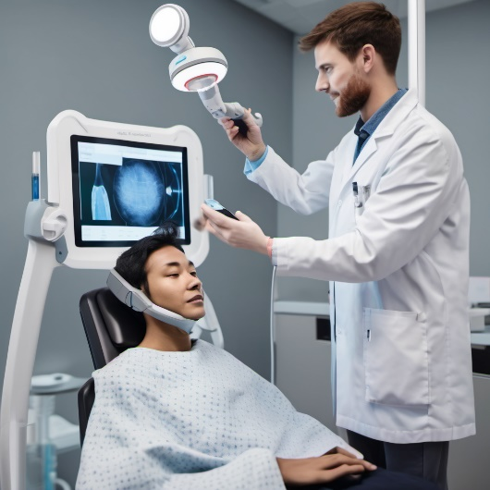

Figure (1): Device used for skin assessment

* **Mobile Application:** This medical app uses fancy technology called CNNs to spot skin problems from pictures. It’s great because anyone can use it to check their skin and catch issues early, especially in areas where doctors aren't easy to reach. Plus, it teaches people about different skin conditions and encourages them to keep an eye on their skin. (Cleveland Clinic, 2022)

The app is super smart thanks to the CNNs, they've learned a lot from tons of pictures and can pinpoint skin conditions well, this helps doctors make better decisions and reduces the chance of mistakes. Plus, the app keeps getting better over time as more people use it and give feedback. So, it's not just about finding problems early but also working together with doctors for better skin care. (Cleveland Clinic, 2022)

# **Chapter 2: Background**

* 1. **Background on Skin Conditions**

Skin is the most powerful protection of organs. It acts as a waterproof shield to guard the body against extremes of temperature, ultraviolet lights and harmful chemicals. Also, the skin produces vitamin-D which has several important functions, such as having a major role in the absorption of calcium and promoting skeletal health. However, this important part of the body can be affected by several factors, such as pollution, poor immunity, viruses, unhealthy lifestyle and ultraviolet lights. Therefore, various skin diseases (such as psoriasis, seborrheic dermatitis, rosacea, acne and skin cancer) can occur.

Skin diseases are important public health problems and one of the most widespread kinds of illnesses worldwide. They affect people of all genders and ages from different countries and ethnicities (Lancet, 2019). The World Health Organization (WHO) webinar on 21 October 2020 handled neglected tropical skin diseases to reach the 2030 road map targets and enhance early detection, timely treatment, morbidity management, disability prevention (Inf. Syst., 2020). In this webinar, Roderick Hay (who is the advisor at The International Foundation for Dermatology in the UK) said that almost 1 billion people have skin conditions mainly caused by six or seven common skin diseases (Inf. Syst., 2020). However, access to a dermatologist is not always possible due to several factors, such as physical disability, old age, physiological problems, climate conditions, employment, distance, scarcity of dermatologists particularly in rural areas and developing or crowded countries like China. Also, long diagnosing time, subjective diagnosis according to the experience of dermatologists, and high costs are discouraging people from getting dermatological care. Alternative solutions for those issues are usually consulting a dermatologist by video conferencing or sending images. However, consulting a dermatologist by sending patient images may lead to privacy-related problems because of sharing personal data. Consulting by video conferencing requires internet connections. Also, they are time-consuming for dermatologists since they already serve in-person care. Further, diagnosis by videoconferencing is still based on subjective decisions and may lead to misdiagnosis. To overcome all those problems, automated methods are needed for the detection and classification of skin diseases from images. Automated methods also improve diagnostic accuracy with quantitative values and provide cost-effective and accurate treatment on time. In addition, automated methods help to diagnose illnesses as non-contact which is very desirable when the disease is contagious, or the person has also a contagious disease at the same time. Automated methods can be used without depending on time and location. However, the visual characteristics of skin lesions are very similar. This similarity makes it difficult to select useful features from images. Therefore, automated image classification, which depends highly on lesion features, is a challenging task.

Spotting skin problems early is important because it helps get treatment started sooner, which can stop things from getting worse, skin issues can be anything from just annoying to serious, like cancer.

If we don't catch them early, skin problems can get worse, symptoms can get worse, and treatments might not work as well, that's why it's important to spread the word about keeping an eye on your skin and getting help if you notice anything weird or concerning.

It’s also important to see a healthcare provider if you have any concerns about your skin, they can provide professional insight, perform necessary tests, and recommend appropriate treatments. Remember, early detection and timely intervention can significantly improve outcomes and prevent potential complications, taking proactive steps to monitor your skin health and seeking medical attention when needed are essential for maintaining overall well-being. (Cleveland Clinic, 2022).

* 1. **Importance of Skin Self-Examination**

Skin self-examination is a proactive approach to monitoring one's skin health and detecting any abnormalities early on. By regularly inspecting the skin for changes such as new moles, alterations in the size, shape, or color of existing moles, or other unusual features, individuals can identify potential signs of skin cancer and other dermatological conditions, this practice is particularly crucial for those with a history of sun exposure, fair skin, or a family history of skin cancer, as they may be at higher risk. By engaging in skin self-examination, individuals empower themselves to become active participants in their healthcare, fostering a sense of agency and control over their well-being. (Ahuja, 2019)

Moreover, skin self-examination serves as an invaluable tool for promoting early detection and timely intervention in skin conditions, detecting skin cancer and other dermatological issues at an early stage significantly increases the chances of successful treatment and favorable outcomes, educational resources and awareness campaigns play a vital role in promoting the importance of skin self-examination, guiding how to conduct thorough examinations and recognize warning signs, by disseminating information and fostering a culture of skin health awareness, these initiatives empower individuals to take proactive steps towards safeguarding their skin and overall health. (Ahuja, 2019)

In conclusion, skin self-examination is not only a preventive measure but also a proactive strategy for promoting skin health and well-being. By fostering a habit of regular inspection and awareness of changes in their skin, individuals can play a vital role in the early detection and intervention of skin conditions, including skin cancer. Educational efforts and public health campaigns are essential in promoting the importance of skin self-examination and empowering individuals to take charge of their skin health, ultimately leading to improved outcomes and enhanced quality of life. (Ahuja, 2019)

* 1. **The function of AI and CNNs in Dermatology**

As the booming of the deep learning era, particularly with the developments in Convolutional Neural Networks (CNNs), CNN-based techniques have drawn great attention to achieve high performance in image classification and have been proposed to use in dermatology. The authors in Ref. reported that new classifiers based on machine-learning outperform dermatologists in recognizing skin lesions and their roles in clinical works should be increased. To increase the accuracy of those classifiers, the trend is to construct more complex and deeper network models. However, those network models require large amounts of computational resources (more powerful GPUs) and cannot be deployed on low-specification environments, such as mobile phones with limited computational capacity (computing power) and storage conditions. Therefore, CNNs are not suitable to develop a mobile application for real-time image classifications because of low specifications, limited hardware resources (memory and power) and the computing ability of mobile devices. To overcome this problem, in recent years, several lightweight architectures have been designed. A lightweight model reduces the number of model parameters and the computing cost. On the other hand, hardware technologies in mobile phones (such as Mate-10 of Huawei, Pixel-II of Google, iPhone-X of Apple) have been advanced by integrating a “neural engine” into the central processing unit and new functionalities into their cameras. Smart applications have received attention due to the rapid spread of mobile phones that are used everywhere more easily than desktop, laptop and tablet applications (Knowl. Base Syst., 2020).

* 1. **Challenges in Skin Disease Diagnosis**

Even though skin issues are usually seen on the surface, figuring out exactly what's going on can be tough. Sometimes, symptoms look similar, and how they show up can be unusual. Plus, everyone's skin is different, which adds another layer of complexity. If a skin problem isn't diagnosed correctly or it takes too long, it can lead to getting the wrong treatment, making things worse. Dermatologists must use a bunch of methods to get it right, like checking how your skin looks, asking about your medical history, and doing tests like skin biopsies or even fancy imaging to make sure they're on the right track when deciding how to help you. (Brind’Amour, 2014)

* 1. **Ethical and legal issues in AI integration in healthcare**
* With AI becoming a bigger part of healthcare, we've got to make sure we're doing it right. That means thinking about stuff like keeping patients' info private, making sure data is safe, and being clear about how everything works. (Future Learn, 2023)
* There are rules set by official groups that help guide how AI in healthcare is developed, checked, and used. These rules make sure things are done the right way, so patients can trust the technology and the people using it. (Future Learn, 2023)
* Making sure AI in dermatology and healthcare is ethical and works well means teaming up. Doctors, tech experts, ethicists, and policymakers all need to work together to make sure things are done in the best way possible for patients. Collaboration is key to making sure AI helps without causing any harm. (Future Learn, 2023)
  1. **Background on Artificial and Convolutional Neural Networks**

ANN is a special kind of machine learning that is an artificial intelligence approach simulating the structure and functionality of the human brain.

It consists of a network of interconnected nodes representing the neurons and is structured in layers, an Input layer, an output layer, and hidden layers in between to do the processing, each neuron serves as a processing unit equipped with its activation function, The connections between these neurons have weights assigned to it, the neurons receive the input, calculate the weighted sum, then pass them to the activation function to map the inputs to the right outputs, while adjusting the weights using a learning algorithm to improve the accuracy and find the optimal weights (harkiran78, 2020).

CNN is a type of Neural Network that is designed to process grid-like objects, its architecture is Inspired by the Visual cortex in the brain, and it differs from regular ANNs by having distinct layers which are called Convolutional, and Pooling layers, and these layers what enable CNN to operate better on things like images, Convolutional layers has filters also called kernels that captures features like lines and edges, then it’s passed to Pooling layers which reduce the dimensions of the image which improves efficiency while keeping the important features, and finally its output is flattened and passed through a Fully connected layer which is a regular ANN to do the processing and give us the output (Memon, 2022).

In Convolutional Neural Networks (CNNs), activation functions are crucial for introducing non-linearity into the model, enabling it to learn and represent complex patterns. There are several activation functions commonly used in CNNs, each with its own advantages and disadvantages. Here are some of the most popular ones:

* **ReLU (Rectified Linear Unit)**
* **Function**: f(x)=max (0, x)
* **Advantages**:
  + Computationally efficient: Simple thresholding at zero.
  + Helps mitigate the vanishing gradient problem by maintaining positive gradients.
  + Sparsity: Many activations are zero, leading to efficient computation.
* **Disadvantages**:
  + Dying ReLU problem: Neurons can get stuck and output zero for all inputs if the weights get updated in such a way that they fall into the negative region permanently.
* **Leaky ReLU**
* **Function**: f(x)=max (0.01x, x)
* **Advantages**:
  + Mitigates the dying ReLU problem by allowing a small, non-zero gradient when the input is negative.
* **Disadvantages**:
  + Introduces a small slope in the negative region which can still slow down training but is generally less of an issue compared to the dying ReLU problem.
* **Tanh (Hyperbolic Tangent)**
* **Function**: f(x)=tanh(x)
* **Advantages**:
  + Can be viewed as a scaled version of the sigmoid function.
  + Outputs are zero-centered, ranging from -1 to 1, which helps with optimization.
* **Disadvantages**:
  + Suffers from the vanishing gradient problem, though less severely than the sigmoid.
* **Sigmoid**
* **Function**:
* **Advantages**:
  + Smooth gradient: Outputs values between 0 and 1, useful for binary classification.
* **Disadvantages**:
  + Outputs are not zero-centered, which can cause issues with gradient-based optimization.
  + Vanishing gradient problem: Gradients become very small for extreme values, slowing down learning.
* **Softmax**
* **Function**:
* **Advantages**:
  + Used in the output layer for multi-class classification problems, converting logits into probabilities.
* **Disadvantages**:
  + Computationally more expensive due to the exponentiation and normalization steps.

# **Chapter 3 – Literature Review**

Because skin diseases are very common, and the idea that a lot of them are detectible just by observing the spot it occurred in, inspired a lot of people to make models for diagnosing skin conditions, these models vary when it comes to the approach used and the exact problem it targeted, here are some similar projects, each tackling distinct skin condition challenges with different approaches.

* 1. **Skin Disease Classification**

Smiti Singhal has made a deep learning model that can discover different skin diseases by using HAM10000 datasets. These datasets contain many dermatoscopic images of common pigmented skin lesions which are helpful in teaching and testing models. Singhal’s model applies several machine learning techniques for realization of its objectives.

The architecture of the model incorporates an Artificial Neural Network (ANN) to capture patterns in images, Convolutional Neural Network (CNN) for classifying pictures and Extreme Gradient Boosting (XGB) Classifier for tabular data classification. These methods when combined make it possible for thorough analysis and accurate prediction of skin cancer types. In terms of image classification tasks, CNN is especially powerful due to its ability to learn spatial hierarchies within data sets while XGB classifier handles structured information more efficiently than other models do because speed has been found to also affect performance.

According to results obtained from Singhal’s research; the accuracy achieved by her CNN model was 76%. This shows promise for deep learning applications in dermatology, but further improvements can still be made. It should be noted however that one limitation of this work is its focus solely on melanoma without considering other types of cancers or even non-malignant conditions like psoriasis vulgaris which might present similar challenges during diagnosis using automated systems based off Hamper-stained tissue sections alone. Moreover, there is currently no mobile application available for use with said model making it less practical outside specialized settings where such software would not require any additional training for those who may wish to employ them within their own clinical practice. (Singhal, 2021)  
  
In summary, Smiti Singhal developed a deep learning model to identify various skin diseases using the HAM10000 dataset, which includes numerous dermatoscopic images of common pigmented skin lesions. Singhal's model combines an Artificial Neural Network (ANN) to detect patterns in images, a Convolutional Neural Network (CNN) for image classification, and an Extreme Gradient Boosting (XGB) Classifier for tabular data classification. This combination allows for comprehensive analysis and accurate prediction of skin cancer types, achieving an accuracy rate of 76%. However, the model's focus is limited to melanoma and does not include other types of cancers or non-malignant conditions like psoriasis vulgaris. Additionally, there is no mobile application for this model, reducing its practicality for widespread use.

The motivation behind this project stems from the limitations identified in Singhal's work. Our project aims to broaden the scope to include various skin conditions beyond melanoma and create a mobile application to make the diagnosis process more accessible and practical for everyday users.

* 1. **Deep Learning Methods for Bug Bite Classification**

Bojan Ilijoski and his colleagues built a project about classifying bug bites based on a Convolutional Neural Network (CNN) model. They used an existing data set combined with additional information obtained by web scraping. This method was applied to create more complete sets of data thus improving models for recognizing different types of insects’ wounds.

This project employs CNN, which is great at spotting patterns and characteristics in photos of bug bites and classifying them. CNNs are exceptional because they efficiently handle image data by understanding spatial structures using convolutional layers indicate that the model had an 86% success rate, an important achievement in such classification projects.

Nonetheless, this study only covers bugs but no other skin conditions hence its scope is limited. However, successful deployment onto a mobile phone application has been done so as people can easily spot these bites while outdoors. Further research should concentrate on broadening its coverage to include more diverse types of dermatological illnesses besides increasing precision even further. (Ilijoski et al. 2023)  
  
In summary, Bojan Ilijoski and his colleagues focused on classifying bug bites using a Convolutional Neural Network (CNN) model. They utilized an existing dataset supplemented with additional data obtained through web scraping. The CNN model efficiently identifies patterns and features in images of bug bites, achieving an 86% success rate. This project also includes a mobile application that allows users to identify bug bites in real-time while outdoors. However, the study is limited to bug bites and does not cover other skin conditions.

The motivation for our project is to extend the capabilities demonstrated by Ilijoski's work by including a wider range of dermatological conditions and improving the precision of diagnosis. By leveraging similar mobile technology, our project aims to provide a more comprehensive solution for skin condition diagnosis.

* 1. **Aysa App by VisualDx**

Aysa is a software produced by **VisualDx** a premiere clinical decision backing company focused on the healthcare industry for mobile use. The purpose of this application is to improve the accuracy of skin disorder diagnoses through the utilization of an extensive library of medical images and advanced machine learning models. The idea behind Aysa is that skin conditions are diverse and may look very different from person to person. (Aysa, n.d.)

To achieve its goals, Aysa has been built on a foundation containing more than 120,000 curated medical pictures covering every color and type of skin there is. This huge dataset enables the program to recognize over 200 various dermatologic diseases. Apple’s CoreML framework was used for integrating Artificial Intelligence into iOS apps to allow real-time analysis of images by machines and suggest possible conditions corresponding to what these represent. (Aysa, n.d.)

Aysa is a must-have tool for healthcare professionals because of its large collection of medical images associated with different skin conditions which are powered by machine learning. It provides insights for common skin concerns through suggesting potential diagnoses and outlining next steps in management thereby streamlining diagnosis making them more accurate (VisualDx, 2018).

In summary, Aysa, developed by VisualDx, uses a vast library of 120,000+ medical images and advanced machine learning via Apple's CoreML to improve skin disorder diagnoses. It recognizes over 200 dermatologic diseases, providing healthcare professionals with management insights and enhancing diagnosis accuracy and accessibility.

Our project aims to enhance dermatological care access and reduce costs associated with traditional diagnosis methods. While progress in deep learning for skin disease detection is noted, gaps remain, including limited scope and mobile application deployment. By leveraging Convolutional Neural Networks (CNNs), our project addresses these gaps, creating a mobile app for efficient diagnosis of diverse skin conditions.

* 1. **Some Other Skin Diagnoses Projects**

The first project uses a subset of Dermnet dataset for its target, with six different classes which are “Normal skin”, “Acne”, “Eczema”, “Vitiligo”, “Tinea”, and “Melanoma”, the model used for classification was VGG-19 architecture and achieved an accuracy of 98% on train set and 82% on the test set (Elbahnasy, 2023).

This other project also uses a subset of Dermnet dataset with six classes, these classes include “Acne”, “Actinic Keratosis”, “Atopic Dermatitis”, “Eczema”, “Nail Fungus”, and “Psoriasis”, the model used for classification was also VGG-19, and it achieved an accuracy of around 97% on train set, and around 69% on validation set (aditikesarwani, 2022).

* 1. **Computer-Aided Diagnosis of Skin Diseases Using Deep Neural Networks**

The research paper 'Computer-Aided Diagnosis of Skin Diseases Using Deep Neural Networks' evaluates various CNN models, including DenseNet, ResNet, and Inception, on the Dermnet dataset with 23 classes, achieving a top-1 accuracy of around 80% (Bajwa et al., 2020).

* 1. **Conclusion**

Our project is motivated by identified gaps and aims to develop a model that can diagnose a wide range of skin conditions, not just specific types, through a mobile application that enhances accessibility and practicality for everyday users. By leveraging advanced deep learning techniques to improve the accuracy and robustness of diagnoses across diverse skin types and conditions, and integrating Convolutional Neural Networks (CNNs) with a comprehensive and diverse dataset, our project aspires to advance the field of teledermatology. The creation of a mobile application will democratize access to dermatological care and provide a practical tool for early detection and management of skin conditions, potentially improving patient outcomes and alleviating the burden on healthcare systems.

Therefore, the reviewed literature demonstrates significant progress in using deep learning for dermatological diagnosis, highlighting both successes and areas for improvement. By building on these findings, our project seeks to contribute to the field of teledermatology by enhancing the scope of diagnosable conditions and ensuring practical, real-time accessibility through mobile technology. This approach not only advances the technological capabilities but also aims to improve healthcare accessibility and patient outcomes, addressing critical needs in the healthcare industry.

# **Chapter 4 – Dataset**

**4.1 Data Importance in AI Applications**

Data plays a crucial role when it comes to building robust ML or DL models, especially in DL where it requires an extensive amount of data to score higher performance (Alzubaidi et al., 2021).

Another factor for a better performing model is the data quality, the data should be representative to the problem we’re tackling to result in a model that can generalize well to real-life problems.

Also, too little data can cause underfitting, while too much low-quality data could cause overfitting (terms will be covered in the methodology section), so balance is the key (Sigari, 2023).

**4.2 Data Requirements**

As discussed previously, both data quantity and quality are important, and for our project we need to obtain images that have good quality of various skin diseases and conditions, and representative to the problem, with RGB colors, Images that looks how the future inputs supposed to look like.

**4.3 Datasets**

For diversity, we will use a combination of datasets, in addition to web-scraped images. The data will be merged into one dataset thus increasing the number of targeted problems.

Our goal is to build a dataset that has most of the skin problems people commonly face around the world, and the datasets we decided to use are:

**4.3.1 Dermnet Dataset**

The dataset comprises of images with 23 different skin diseases. It includes over 19,500 JPEG images with “RGB channels”. Approximately 15,500 images are allocated to the training set, and the remaining images are part of the test set. The resolutions vary, but overall, the images are not extremely high resolution, below is a sample of the dataset:

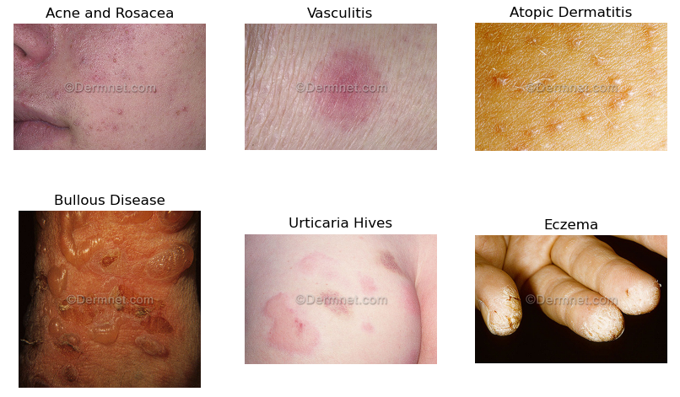

Figure (2) Dermnet dataset samples (DermNet, n.d.)

The dataset classes are distributed as follows:

Figure (3) Dermnet dataset – Train Distribution (DermNet, n.d.)

Figure (4) Dermnet dataset – Test Distribution (DermNet, n.d.)

The dataset is well balanced and covers a diverse range of skin diseases which will help our model generalize better and learn their patterns without biases (DermNet, n.d.).

**4.3.2 Bug bites Dataset**

This dataset contains 841 JPEG Images with “RGB channels” of different Insect bites with originally 11 classes named in Turkish, these classes were translated in English, in addition to combining some of the classes which has similar/same insects, the classes were renamed from: “ari” to Bee sting,”pire” and “insan-pire” to Flea bite, “tahta-kurusu” and “Bed Bug” to Bed Bug bite,”sinek” to Fly bite,”kene” and “Tick” to Tick bite, and lastly “orumcek” to Spider bite., in addition to that, all the images are originally stretched (resized) to a resolution of 640x640 (bug bite dataset, 2024).

Some samples of Bug bite dataset:

Figure (5) Bug bite dataset samples (bug bite dataset, 2024)

**4.3.3 Web-scraped Data**

To complete our custom dataset, we web-scraped 20 JPEG images from google images and made a new class named “Chigger bite” which is a common insect that is known of biting people.

The distribution of the Bug bites Dataset is as shown below:

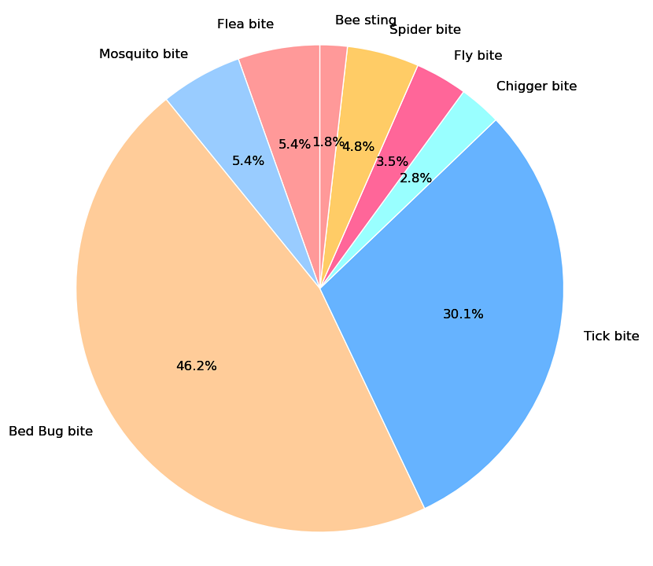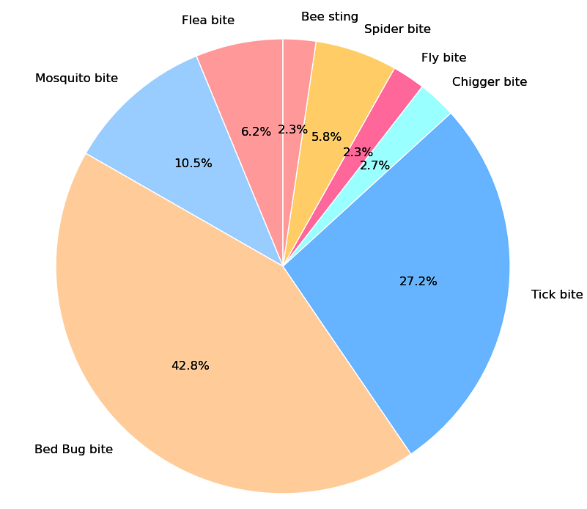

Figure (6) Bug bite dataset – Train Distribution (bug bite dataset, 2024) Figure (7) Bug bite dataset – Test Distribution (bug bite dataset, 2024).

**4.4 Data Integration**

Data integration is the process of combining data from different sources.

The Bug bite dataset is Divided into training, testing and a validation set, but since our biggest dataset (Dermnet) has train and test set only, and this dataset has much less images, we decided to merge test and validation set together, after that we placed Bug bite Dataset’s folders inside it’s corresponding set. (bug bite dataset, 2024).

**4.5 Results**

In conclusion, we were able to create a custom dataset with 20,424 images, divided into 16,165 images as train set and 4,259 images as a test set which is around 80/20 train to test ratio, consisting of 23 different classes using a combination of Dermnet, Bug bite datasets in addition to web-scraped images of “Chigger bites”, All the images are JPEG, have RGB colors, and are taken from cameras which is perfect for our case,

The final “Dermatech Dataset 1.0” where “Bug Bites” classes are merged into “Scabies Lyme” class the distributed is as follows:

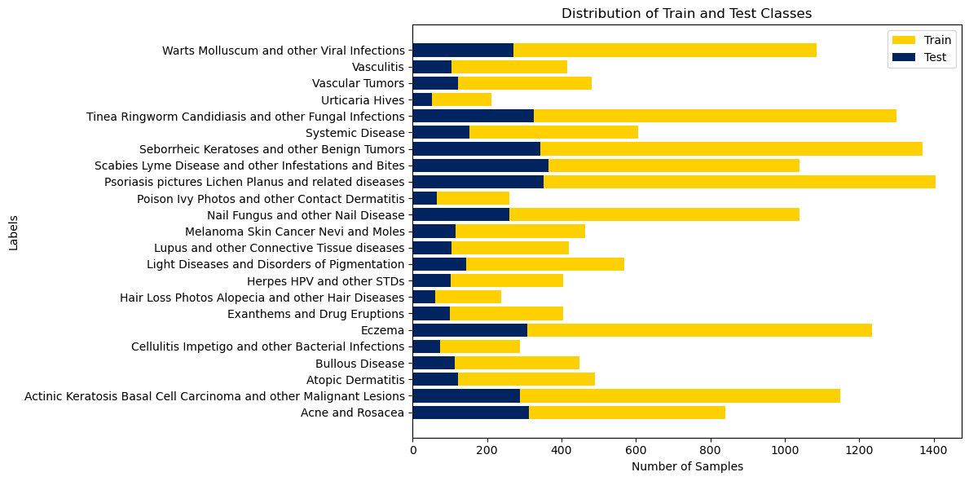

Figure (8) Dermatech 1.0 dataset – Train and Test Distribution

We decided to do 3 experiments, each one using a different subset of this dataset, and monitor the performance of each one.

Second experiment will utilize hierarchical classification technique, where we group related conditions into one broad category, the grouping was done as shown below:

* **Inflammatory and Autoimmune Diseases** include conditions like Acne, Atopic Dermatitis, Eczema, Lupus, Psoriasis, Lichen Planus, and Urticaria.
* **Infectious Diseases** encompass bacterial, viral, fungal, and other infections such as Cellulitis, Herpes, HPV, Tinea, Candidiasis, and Warts.
* **Neoplastic Diseases (Tumors and Cancers)** include benign and malignant tumors like Actinic Keratosis, Basal Cell Carcinoma, Melanoma, Seborrheic Keratoses, and Vascular Tumors.
* **Pigmentation and Light Disorders** include Light Diseases and Disorders of Pigmentation.
* **Drug Reactions and Allergic Conditions** involve Exanthems, Drug Eruptions, and Contact Dermatitis.
* **Systemic and Other Diseases** include Bullous Disease, Systemic Disease, and Vasculitis.
* **Hair and Nail Disorders** cover Hair Loss, other Hair Diseases, and Nail Fungus.
* **Bug Bites** include bites and infestations from Bed Bugs, Bees, Chiggers, Fleas, Flies, Mosquitoes, Spiders, Ticks, and Scabies.

And the result distribution of this dataset is:

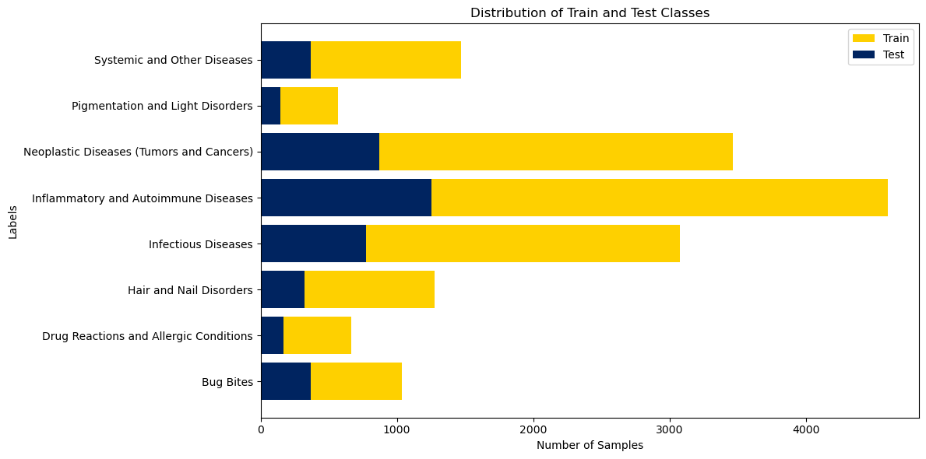

Figure (9) Dermatech 2.0 dataset – Train and Test Distribution

And for the last experiment, we only used some classes that are common and important diseases and conditions, that also have distinct features, for a more reliable outcome, this subset distribution result is shown in the figure below:

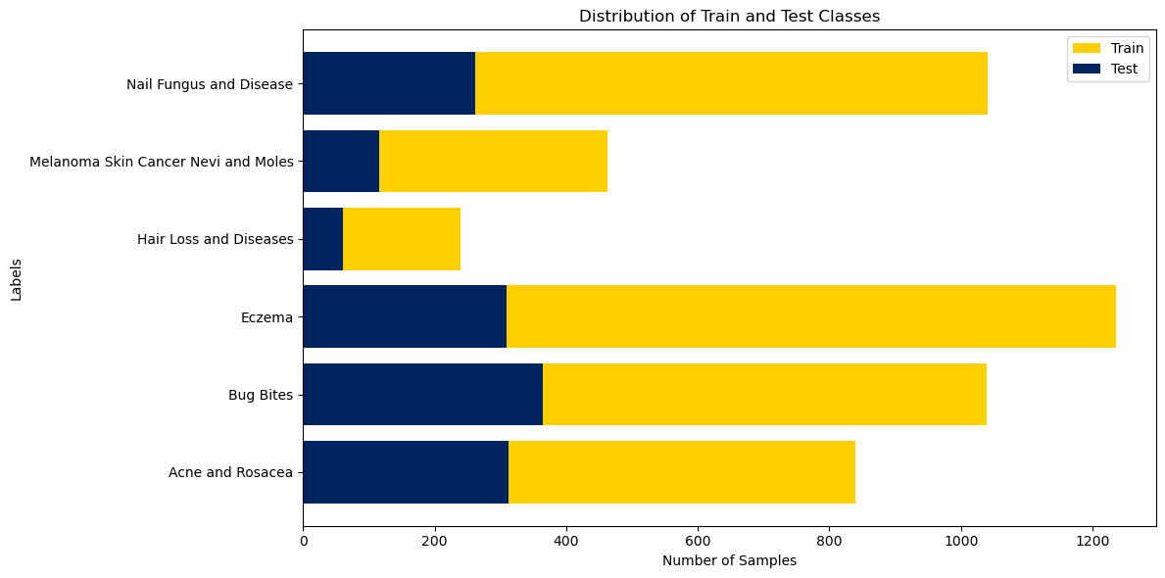

Figure (10) Dermatech 3.0 dataset – Train and Test Distribution

# **Chapter 5 – Methodology**

In this section, we will present the roadmap for the execution of our model development journey, beginning from data acquisition, and ending in the deployment of our mobile application. This roadmap will be divided into phases, each serving a critical step in the methodology. These phases are:

**5.1 Data Collection and Preprocessing:**

**a. Data Collection and Integration**

Combining Multiple datasets with web-scraped data and integrate them together, thus making a custom dataset, discussed more in the previous chapter.

**b. Data Preprocessing**

First step before using these images to extract the features and train our model, is resizing all images to a resolution of 224x224, which is the standard size for most CNN architectures, then use Data Augmentation techniques to expand the dataset instances using random vertical and horizontal flipping with probability of 0.5, and random cropping, then transform these images into tensors for our model to understand, and after that, normalize pixel values by dividing it with 255.

* **Normalization**

Normalization involves scaling the pixel values of images to a standard range, typically [0, 1] or [-1, 1]. This step helps in speeding up the convergence of the model during training.

Normalization is necessary because it ensures that the input features are on a similar scale, preventing any single feature from dominating the training process. It also helps in stabilizing the gradients during backpropagation.

* **Data Augmentation**

Data augmentation artificially increases the size of the training dataset by creating modified versions of the original images. This technique helps in improving the generalization of the model by exposing it to a variety of image transformations.

Common Augmentation Techniques and Their Mathematical Transformations:

**Rotation:** Rotating the image by a random angle θ

Rotated Image(x,y) =

**Scaling:** Resizing the image by a factor s.

Scaled Image(x,y) =

**Translation:** Shifting the image horizontally or vertically by a distance tx​ and ty​.

Translated Image(x,y) =

**Flipping:** Horizontally or vertically flipping the image.

Flipped Image(x,y) =

**5.2 Model Selection and Training:**

**a. Framework Selection**

According to Çanakçı, DL frameworks are “powerful software libraries that simplify the development and implementation of neural networks.”, These frameworks provide users with tools and environments for building, training, and deploying models, equipped with advanced algorithms and optimized functions, in addition to hardware acceleration support to utilize GPUs which makes training significantly faster.

There are several factors when considering a DL framework and it could be summarized in documentation and support, ease of use, performance, and compatibility with other libraries (Çanakçı, 2023).

The frameworks which will be considered in our project are TensorFlow-Keras, and pytorch, These frameworks are one of the most popular frameworks for deep learning, for its user-friendliness, and it’s support for CUDA which is a parallel computing platform that allows users to utilize their Nvidia GPU to boost training performance, but due to performance and compatibility issues faced while working with TensorFlow-GPU, we decided to work with pytorch.

**b. Transfer Learning**

Building a robust model requires a large amount of data, TL is a technique in ML that allows us to use pre-trained models on big datasets and use its weights as a base, then fine-tune it to solve current problems, we use TL when we have a limited amount of training data, however the source data must be somewhat related to avoid negative transfer which reduces model’s performance.

TL is used in image classification especially with CNN Architectures and shows very promising outcomes (Hosna et al., 2022).

And nowadays, most pre-trained CNN models use ImageNet, which is a dataset comprises of over 14 million images divided into 70% to 30% train to test ratio and is used to train various ML models.

**c. Hyperparameters**

The hypermeters such as learning rate, batch size, and number of epochs are crucial in training neural networks like those used in DermaTech. The learning rate determines the step size in updating model weights, impacting convergence speed and stability. Batch size affects the efficiency and generalization ability of the model by determining the number of samples processed per iteration. Meanwhile, the number of epochs controls how many times the model iterates over the entire dataset, influencing both model complexity and the risk of overfitting. Optimal hyperparameter selection involves balancing these factors to achieve efficient training dynamics and convergence towards a model that generalizes well to new data. (Shafi and Assad, 2023)

**d. CNN Stages**

A CNN is a type of deep neural network designed to process structured grid-like data, such as images. It consists of multiple layers that perform specific operations to learn hierarchical representations of the input data. (Ali, 2024)

**1. Convolutional Layer:**

* Convolutional layers apply filters (kernels) to the input image to extract features such as edges, textures, and patterns.

(X∗W)(i,j)=m∑​n∑​X(m,n)⋅W(i−m,j−n)

**2. Activation Functions (e.g., ReLU):**

* Activation functions introduce non-linearity into the network, allowing it to learn complex patterns and make the network more expressive.

ReLU(x)=max(0,x)

**3. Pooling Layer:**

* Pooling layers downsample the feature maps, reducing their spatial dimensions while retaining important features.

MaxPooling(X)(i,j)=m,nmax​X(i⋅s+m,j⋅s+n)

**4. Fully Connected Layer:**

* Fully connected (or dense) layers integrate features from the previous layers to make final predictions.

Y=ϕ(W⋅X+b)

**5. Softmax Layer:**

* The softmax layer is typically used for multi-class classification tasks, converting raw scores into probabilities.

In a CNN, layers are sequenced to extract detailed features (convolutional), introduce complexity (activation functions), and reduce dimensions (pooling). Fully connected layers integrate these features for precise classification, while the softmax layer ensures outputs are probabilistic and mutually exclusive, enabling accurate recognition of objects in images (Ali, 2024)

**d. CNN Architecture Selection**

There are a lot of different CNN architectures to choose from, each with its own characteristics, these architectures differ in many aspects, depth, the order of convolutional and other layers, activation function usage, number and size of kernels, amount and kind of pooling applied.

The model architectures focused on in this project are:

* **VGGNet:** It’s a CNN Architecture used very commonly in image recognition, most known variations of this architecture are VGG-16 and VGG-19, and the number in its name refers to model’s weighted layers.

VGG-19 takes a 224x224 RGB Image as an input, uses 16 Convolutional layers with small 3x3 kernels to capture features equipped with ReLU activation function, the stride is fixed to 1 pixel, and after every few convolution layers, it is followed by max-pooling layer and its performed over 2x2 pixel, then it’s passed through 3 Fully-connected layers, first 2 with 4069 neurons each with ReLU activation function and last layer contains 1000 neurons equipped with softmax activation function thus predicting 1000 different classes (Simonyan and Zisserman, 2015).

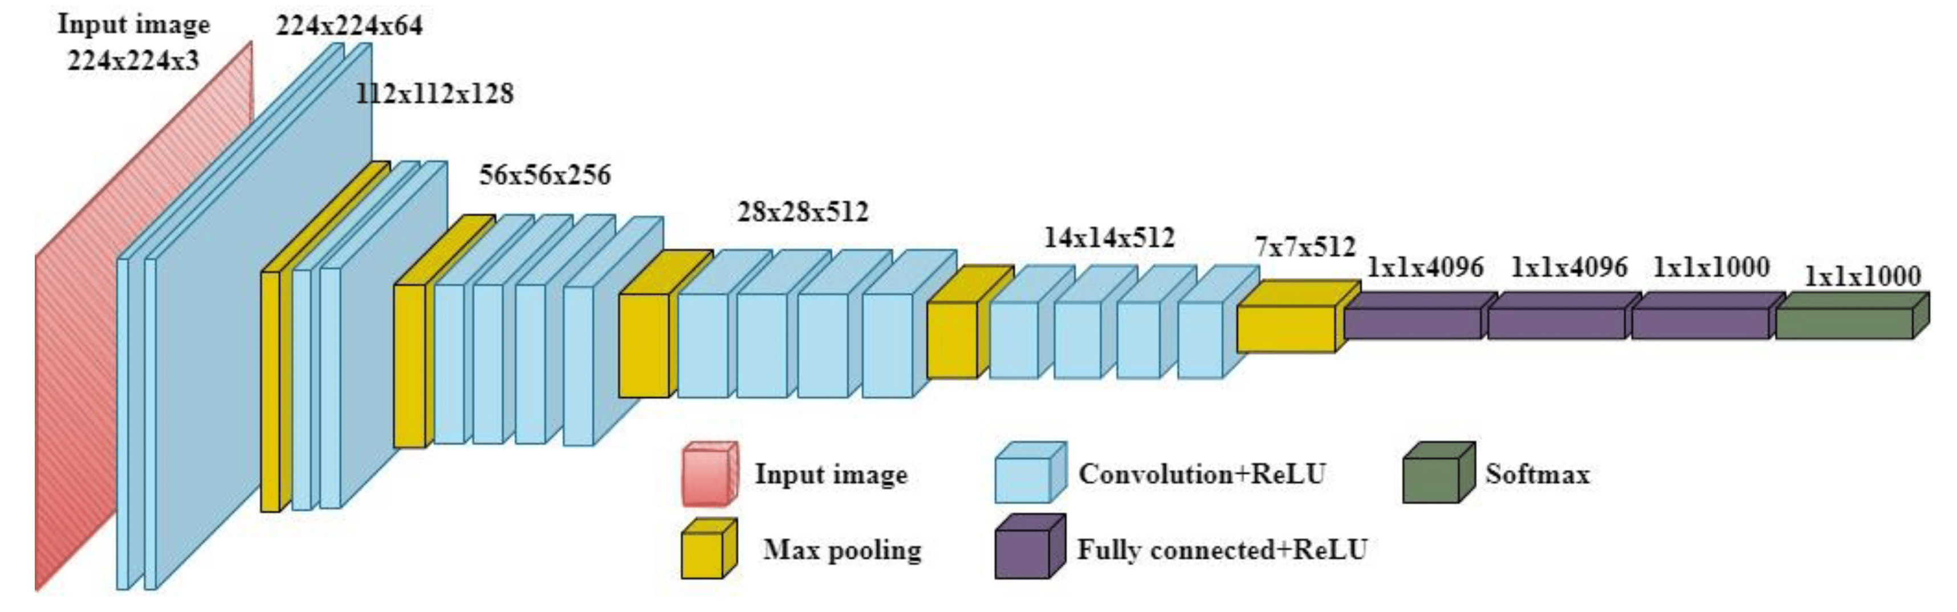

Figure (11) VGG-19 Architecture (Simonyan and Zisserman, 2015)

This architecture was chosen because it provided good outcomes when it was used in the related work mentioned before, using ImageNet weights.

* **ResNet:** refers to Residual networks, which is mainly inspired by VGGNet, is another commonly used architecture in image recognition, it has many variations like ResNet-50, ResNet-101, and Resnet-152, and the numbers refer to the depth of the variant.

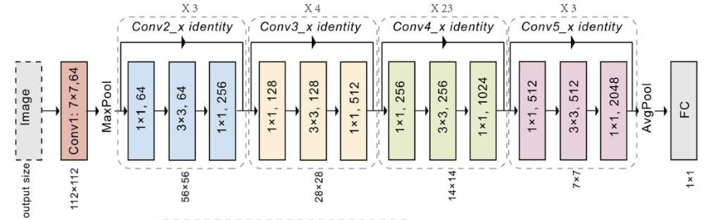

Figure (12) ResNet Architecture (He et al., 2015)

Key differences between VGGNet and ResNet Architectures is using Batch Normalization, the implementation of Residual blocks, which are used to skip few layers, and in return improve optimization for deeper models and eliminates exploding and vanishing gradients leading to a better performance, in addition to using deeper architecture than VGGNet.

It has the same input size of 224x224, and the first layer uses kernel size of 7x7, and after last convolutional layer, it utilizes average pooling (He et al., 2015).

This model architecture was chosen for its high performance in related work, pre-trained with ImageNet dataset.

* **DenseNet:** DenseNet-201, a variant of DenseNet, is a notable architecture in image recognition, utilizing dense connectivity where each layer receives input from all preceding layers within the block. This design fosters strong feature reuse and alleviates gradient vanishing issues, enhancing training efficiency. It operates on 224x224 RGB images with 3x3 convolutional layers, using batch normalization and ReLU activation throughout. After dense blocks, it employs transition layers with 1x1 convolutions and 2x2 average pooling. The network culminates in a global average pooling layer followed by a fully connected layer with 1000 neurons and softmax activation, facilitating classification across 1000 classes, pre-trained typically on ImageNet for superior performance in relevant studies (Huang et al., 2017).

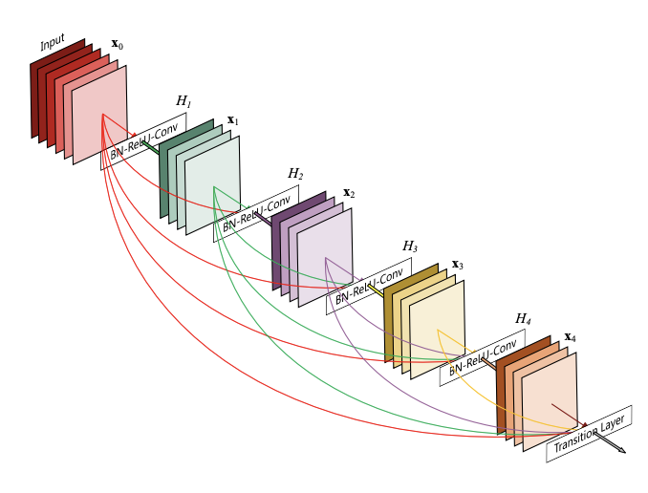

Figure (13) DenseNet Architecture (Huang et al., 2017)

And lastly, we are modifying the chosen model Architectures by changing the input size to match the image size chosen earlier, and the output size to match the number of target classes.

In conclusion, our project utilized VGG-19, ResNet-152, and DenseNet-201 to investigate the impact of varying network depths on performance outcomes. These models, with their distinct architectural depths of 19, 152, and 201 layers respectively, provided a comprehensive comparison. The results will highlight how differences in network depth can influence accuracy and other performance metrics, offering valuable insights into the relationship between model complexity and performance.

**e. Model Compiling, Training and Fine-Tuning**

using *AdamW* as an optimizer, with default learning rate of 0.001 and weight decay of 0.001, use *CategoricalCrossEntropy* criterion (loss function) and using *ReduceLROnPlateau* scheduler with a factor of 0.5 and patience of 2.

For training the model, we will use 10 epochs, and a batch size of 32, in addition to early stopping and setting it to accuracy mode which helps avoid overfitting the model.

in addition to implementing *k-fold* cross validation of 5 (10 epochs each) to fix overfitting and underfitting problems, with class weights set to balanced.

Figure (14) Model Fit: Underfitting vs. Overfitting (Amazon AWS)

**5.3 Model Evaluation and Testing:**

To assess the model's performance, we will use confusion matrix, confusion matrix will allow us to get number of correct and incorrect classifications for each class, these values are called, True positive (TP) where the model predicts a class as positive and it is correct, True negative (TN) where the model predicted the class to be negative and it was correct, False positive (FP) where the model predicts the class as positive but it was wrong, and lastly False negative (FN) is when the predicted class is negative and it’s wrong (Beheshti, 2022).

These values will later help us to calculate other metrics derived from them, metrics like:

* **Accuracy:**
* **Precision:**
* **Recall:**
* **F1 Score:**

These metrics will help us have a better insight into our model’s performance for furthermore enhancement and hyperparameter tuning.

Finally, saving the trained model’s weights to use it for classifying in the future.

**5.4 Mobile App Development, Testing, and Deployment:**

The application, named "Dermatech," is designed to be a user-friendly tool for diagnosing skin conditions. It features a clean and straightforward interface that guides users through the sign-in and sign-up process effortlessly. The main screen allows users to either upload an image from their device or take a photo using the camera, and then receive an instant diagnosis using an advanced image analysis model. Users can track their skin health over time through a history page that saves all previous scans. The app also provides a news section with articles related to dermatology and skin health, as well as detailed information about diagnosed conditions.

In addition to its primary functions, "Dermatech" includes several user-centric features. The settings allow users to change the language to Arabic and update their username and password. The contact page lists three team members whom users can reach out to for assistance, and the profile page displays the user's username, email, and date of birth. There is also a share service that enables users to share their diagnostic results with others. With a focus on accessibility, security, and accurate results, "Dermatech" aims to improve dermatological care and empower users with valuable health information.

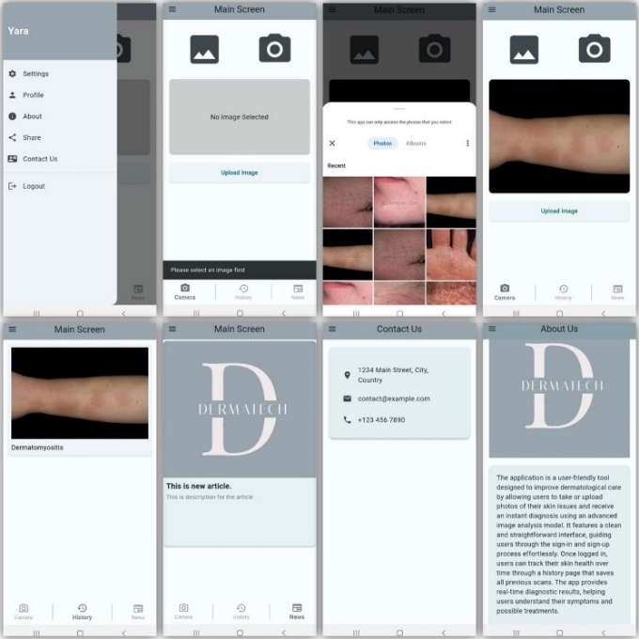

Figure (15) Dermatech Application Interface

Using Django Rest Framework (DRF) API, you can seamlessly integrate the backend and frontend for a skin disease detection app. The API manages image uploads, processes them with the trained model, and retrieves classification results, ensuring efficient communication and accurate diagnoses for users.

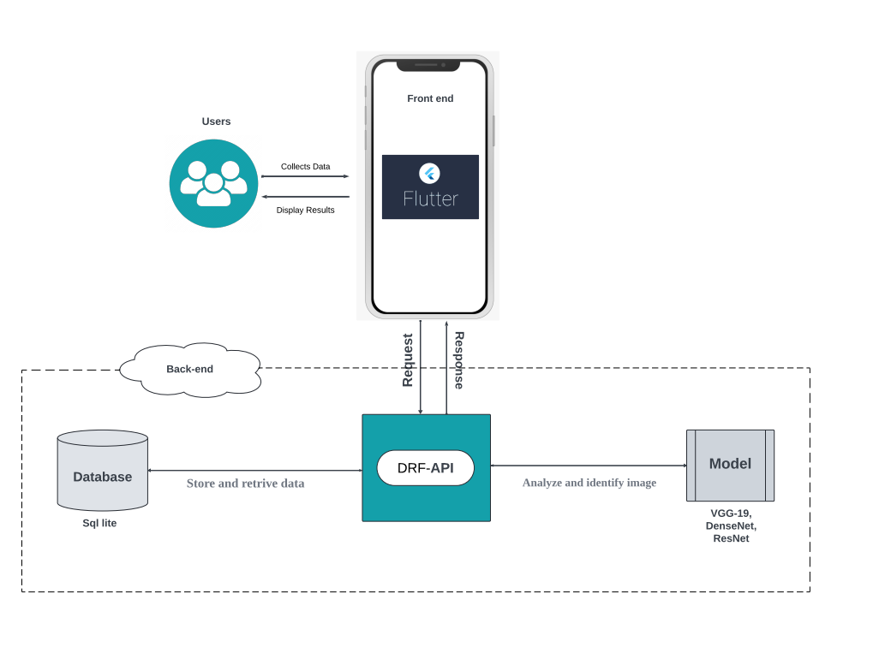

Figure (16) Dermatech Application Architecture

This chapter outlines the roadmap for developing and deploying a mobile application for skin condition diagnosis, divided into four phases. **Data Collection and Preprocessing** involve creating a custom dataset by combining multiple datasets with web-scraped data, standardizing images to 224x224 resolution, applying data augmentation, and normalizing pixel values. **Model Selection and Training** focuses on using PyTorch, leveraging transfer learning with VGG-19, ResNet-152, and DenseNet-201, and fine-tuning these models. **Model Evaluation and Testing** employs metrics like accuracy, precision, recall, and F1 score to assess performance, using a confusion matrix for detailed analysis. Finally, **Mobile App Development, Testing, and Deployment** involves creating the "Dermatech" app, integrating the trained model via Django Rest Framework (DRF) API for efficient image processing and accurate diagnoses, while ensuring user-friendly features and accessibility.

# **Chapter 6: Results**

In this section, we will present the results of 3 different experiments achieved by each model architecture, the evaluation is done by using a normalized confusion matrix, and other metrics like accuracy, weighted average for precision, recall, and f1-score, these results will be explained, and discussed furthermore in the discussion section, starting from the deepest architecture to less deeper ones.

**Experiment 1.0**

This experiment used DT 1.0 dataset, the result obtained shows an **accuracy** of 42%, the weighted average of **precision**, **recall**, and **f1-score** are 43%, 42% and 42% respectively with “Scabies Lyme (Bug Bites)” class having the highest **precision** and **f1-score** of 87% and 80%, and both “Scabies Lyme” and “Nail Fungus and other Nail Disease” class with highest **recall** of 75%.

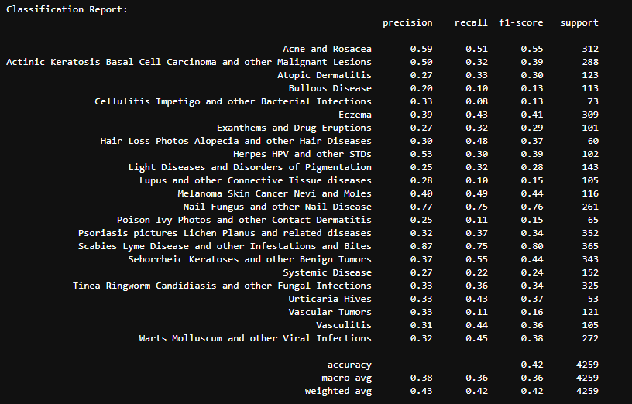

Figure (17) DenseNet-201 Classification Report 1.0

The model achieved the highest accuracy in “Scabies Lyme”, “Acne and Rosacea”, and “Eczema” class, while it showed bad generalization in most of the remaining classes.

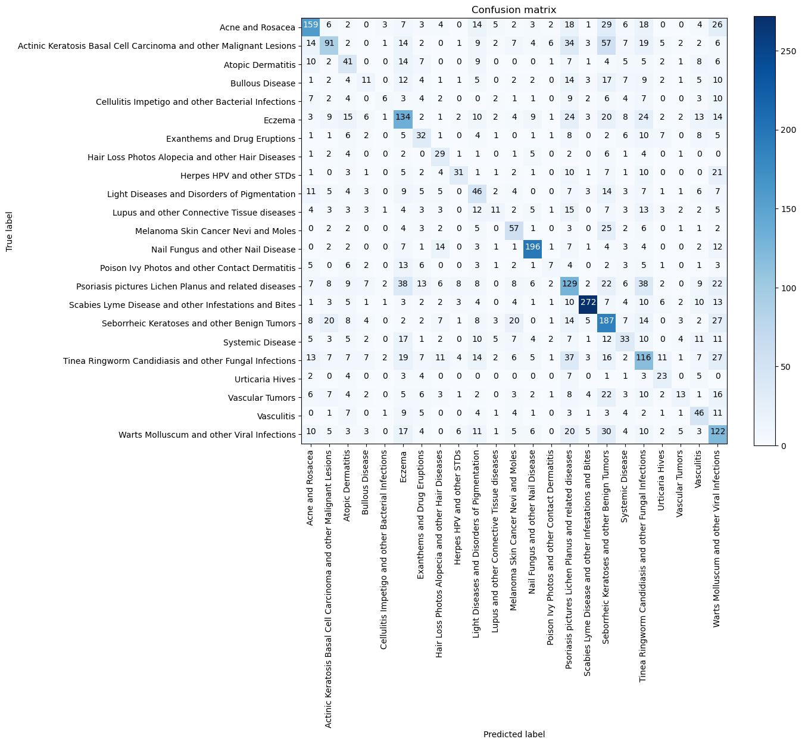

Figure (18) DenseNet-201 Classification Report 1.0

**Experiment 2.0**

This experiment used DT 2.0 dataset, as shown in Figure 16, Densenet-201 obtained an **accuracy** of 51%, the weighted average of **precision**, **recall**, and **f1-score** are 57%, 51%, and 52% respectively, with Bug Bites class having the highest **precision** and **f1-score** of 96% and 82%, and Hair and Nail Disorders class with highest **recall** of 74%.

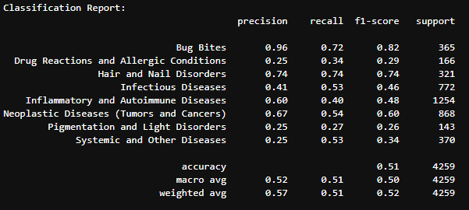

Figure (19) DenseNet-201 Classification Report 2.0

And as shown in Figure 17 the model was successfully able to classify 74% of Hair and Nail Disorders class and 72% of Bug Bites class, and 54% in Neoplastic Diseases class of the test set, while the worst performance was in Pigmentation and Light Disorders class where the model only correctly predicted 27% of it.

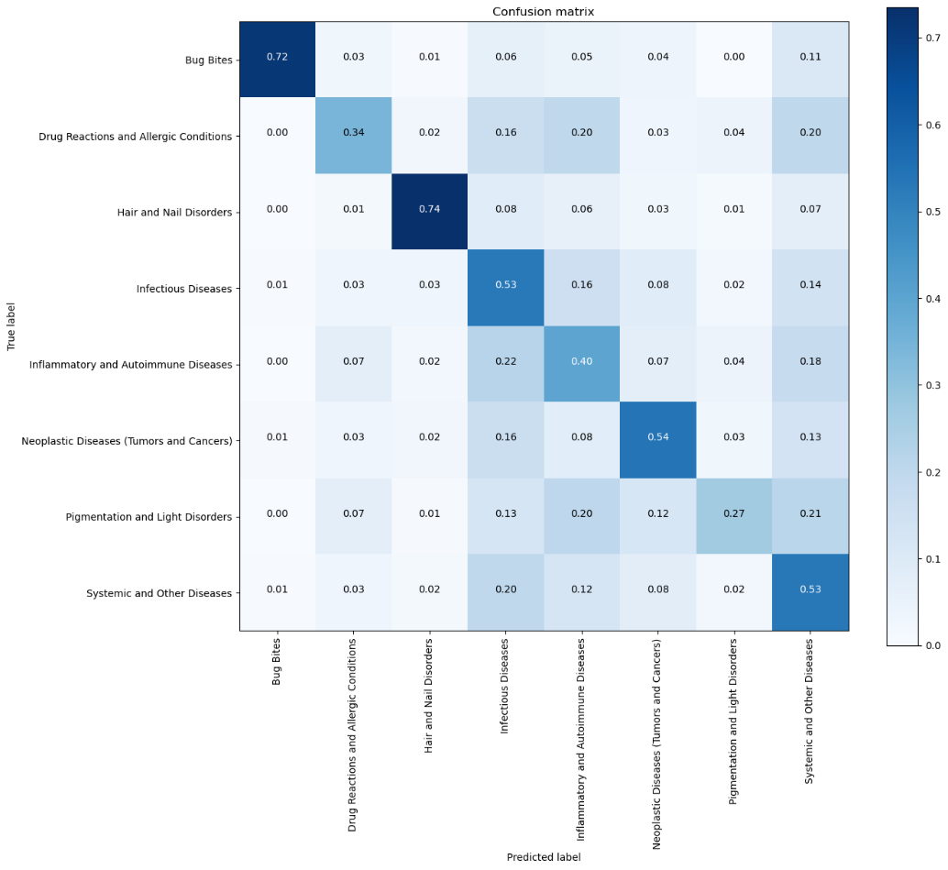

Figure (20) Normalized DenseNet-201 Confusion Matrix 2.0

Secondly, ResNet-152 model obtained an **accuracy** of 46%, the weighted average of **precision**, **recall**, and **f1-score** are 54%, 46%, and 48% respectively, with Bug Bites class having the highest **precision** and **f1-score** of 68% and 72%, and Hair and Nail Disorders class with highest **recall** of 79%.

Figure (21) ResNet-152 Classification Report 2.0

From the Normalized Confusion Matrix below, the model was successfully able to classify 79% of Hair and Nail Disorders class and 76% of Bug Bites class, and 55% in Neoplastic Diseases class of the test set, while the worst performance was Systemic and Other Diseases class where the model only correctly predicted 29% of it.

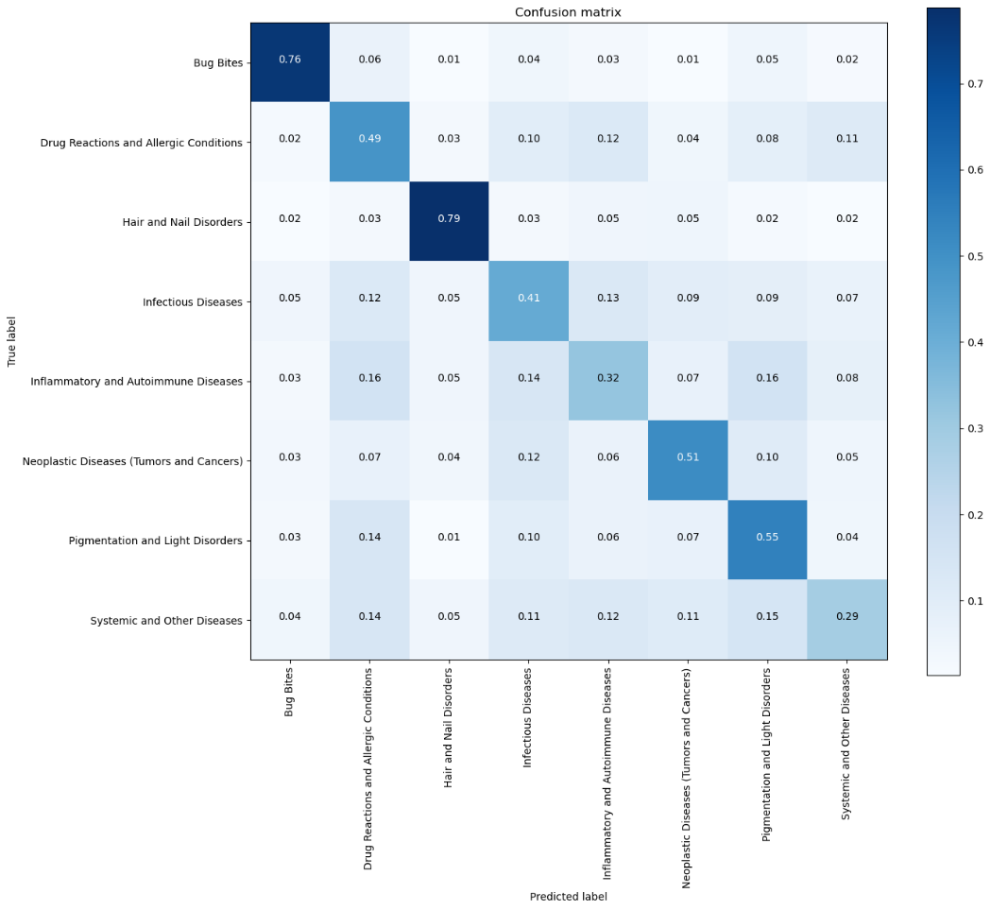

Figure (22) Normalized ResNet-152 Confusion Matrix 2.0

VGG-19 model on the other hand obtained an **accuracy** of 41%, the weighted average of **precision**, **recall**, and **f1-score** are 50%, 41%, and 43% respectively, with Bug Bites class having the highest **precision** and **f1-score** of 96% and 78%, and Hair and Nail Disorders class with highest **recall** of 82%.

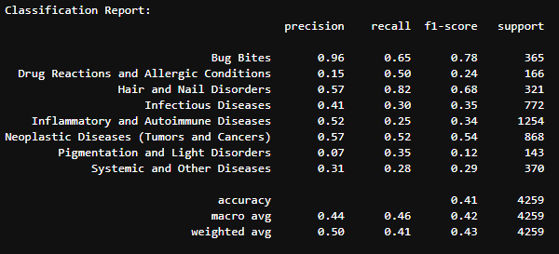

Figure (23) VGG-19 Classification Report 2.0

And lastly From the Confusion Matrix below, showing that the model was successfully able to classify 82% of Hair and Nail Disorders class and 65% of Bug Bites class, and 52% in Neoplastic Diseases class of the test set, while the worst performance was Inflammatory and Autoimmune Diseases class where the model only correctly predicted 25% of it.

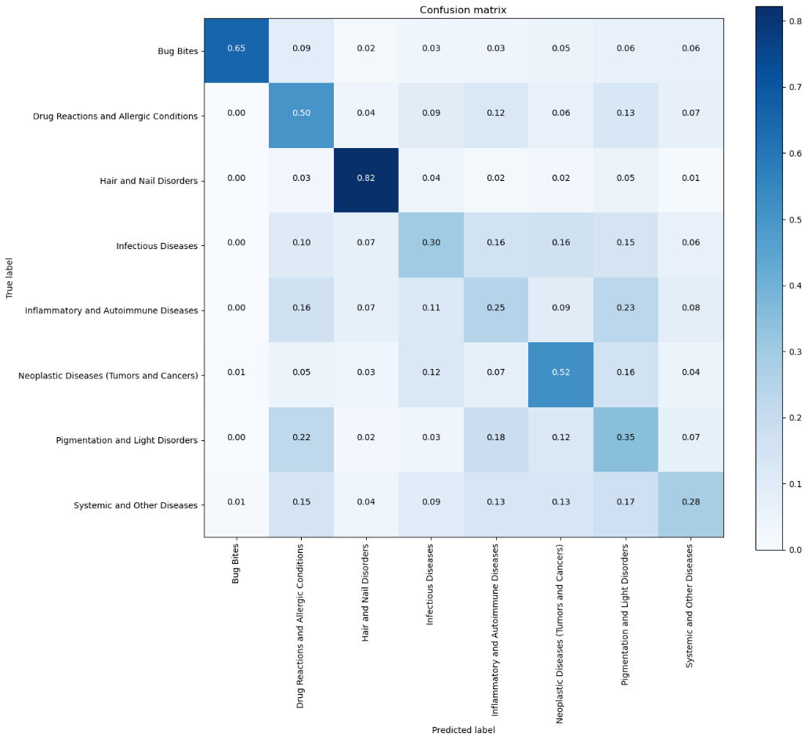

Figure (24) Normalized VGG-19 Confusion Matrix 2.0

**Experiment 3.0**

This experiment used DT 3.0 dataset, Densenet-201 obtained an **accuracy** up to 82.4% on the training set, an average accuracy of 83% on validation set, and as shown in the classification report below, an accuracy of 79% on test set.

The weighted average of **precision**, **recall**, and **f1-score** are 83%, 79%, and 80% respectively, with Bug Bites class having the highest **precision** and **f1-score** of 95% and 88%, and “Hair Loss and Diseases” class with highest **recall** of 88%.

Figure (25) DenseNet-201 Classification Report 3.0

The model was successfully able to classify “Hair Loss and Diseases” the highest with 88% accuracy, while the worst performing class was “Eczema” class where the model only correctly predicted 72% of it.

Figure (26) Normalized DenseNet-201 Confusion Matrix 3.0

ResNet-152 on the other hand obtained an **accuracy** up to 83.2% on the training set, an average accuracy of 83.6% on validation set, and as shown in the classification report below, an accuracy of 78% on test set.

The weighted average of **precision**, **recall**, and **f1-score** are 82%, 78%, and 79% respectively, with “Nail Fungus” class having the highest **precision of 93%,** “Hair Loss and Diseases” class with highest **recall** of 87%, and “Bug Bites” class with the highest **f1-score** of 87%.

Figure (27) ResNet-152 Classification Report 3.0

The model was successfully able to classify “Hair Loss and Diseases” the highest with 87% accuracy, while the worst performing class was “Eczema” class where the model only correctly predicted 73% of it.

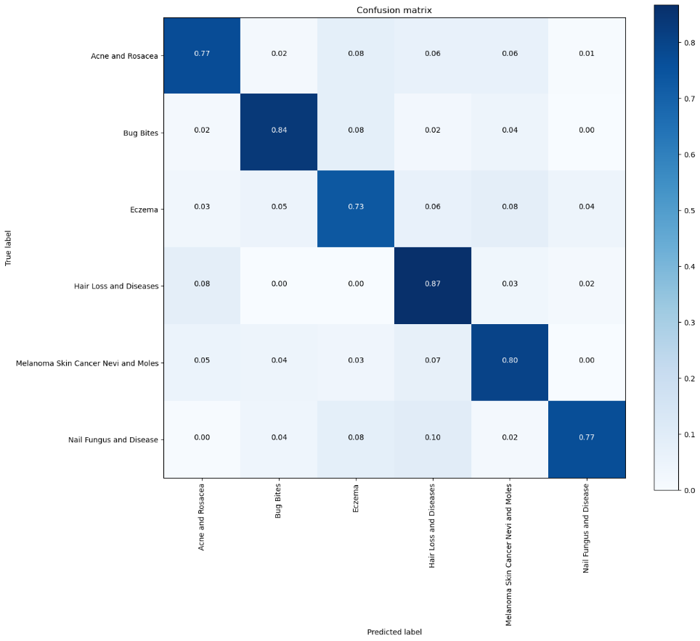

Figure (28) Normalized ResNet-152 Confusion Matrix 3.0

Lastly VGG-19 model obtained an **accuracy** of around 92.1% on training set, and average accuracy of 92% on validation set, and an accuracy of 83% on test set, the weighted average of **precision**, **recall**, and **f1-score** are 84%, 83%, and 83% respectively, with “Bug Bites” class having the highest **precision** of 93%, “Acne and Rosacea” class with highest **recall** and **f1-score** of 95% and 91% respectively.

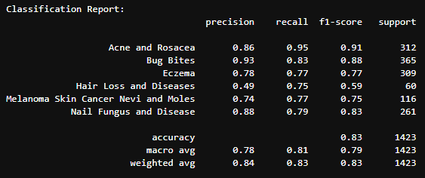

Figure (29) VGG-19 Classification Report 3.0

The model was successfully able to classify “Acne and Rosacea” class the highest with 95% accuracy, while the worst performing class was “Eczema” and “Melanoma” class where the model predicted 77% correctly of it.

Figure (30) Normalized VGG-19 Confusion Matrix 3.0

In summary, we have presented the results of 3 different experiments, and the performance metrics for three deep learning architectures DenseNet-201, ResNet-152, and VGG-19.

Experiment 1.0 had the worst overall metrics, and an accuracy of 42% due to inconsistency in the data, the model couldn’t generalize well and learn the patterns properly.

Experiment 2.0 achieved a slightly better performance, with the highest accuracy with DenseNet model of 51%, but since the result didn’t meet the expectations, the idea of hierarchal classification was terminated.

And lastly Experiment 3.0 achieved the highest performance, with VGGNet model reaching an accuracy 83%, due to the use of classes with distinct features and well-balanced distribution.

# **Chapter 7: Discussion**

This research aimed for building a custom dataset using a combination of already existing datasets, and other web-scraped data, in addition to provide a simple and easy to use mobile application for skin assessment, helping in saving time, and to early detect serious conditions, utilizing state-of-the-art CNN architectures, such as DenseNet, ResNet, and VGGNet, pre-trained using TL technique on ImageNet dataset.

From Experiment 1.0, we can clearly see that DenseNet model didn’t provide a good performance due to data quality issues, even with hyperparameter tuning, the model appeared to have highest accuracy limited to the "Scabies Lyme," "Acne and Rosacea," and "Eczema" classes, which means it performed well in these specific areas. The poor generalization to most of the other classes suggests that the model may need more diverse training data or further tuning to improve its performance across all skin conditions in the dataset, which led us to do different experiments to achieve better results.

Experiment 2.0 showed a slightly better performance metrics overall with DenseNet achieving the highest score in all the metrics (accuracy, precision, recall, and f1-score) and it’s most likely due to its deeper architecture and the use of densely connected layers which facilitate better gradient flow and feature reuse.

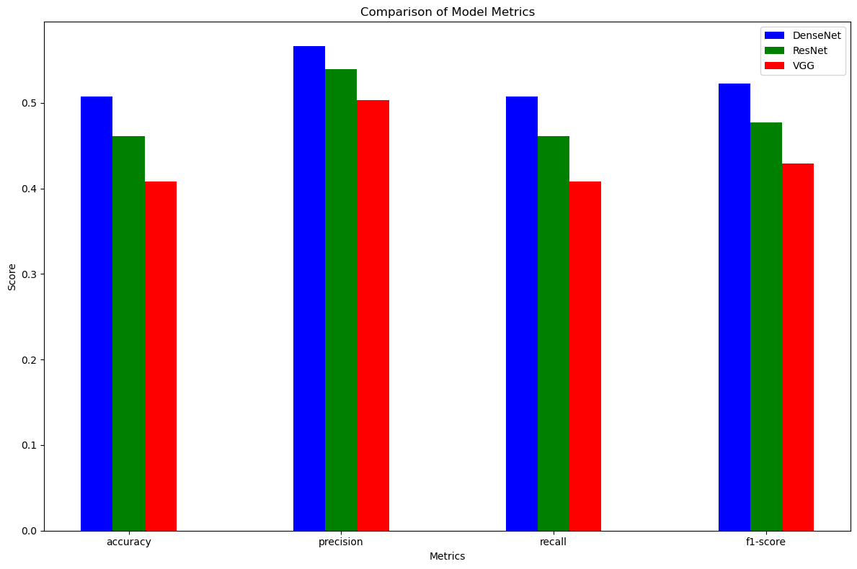

Figure (31) Models Metrics Comparison 2.0

If we go back to Experiment 2.0 confusion matrices, we see an interesting pattern, all three different architectures have very similar results when it comes to the best and worse performing classes, which suggests a bias towards the good performing classes.

Also, the data quality and distribution are affecting the over all performance, the important features that helps the model do the classification are getting lost in with other features, or in other words there are too much distraction and noise in the dataset.

Experiment 3.0 on the other hand showed good metrics scores across all classes, the models appeared to be better generalized to the dataset, and this experiment shows that VGG model did better that the other architectures, since the subset of the dataset is simpler, the more deep and complex models could lead to worse generalization and overfitting problems.

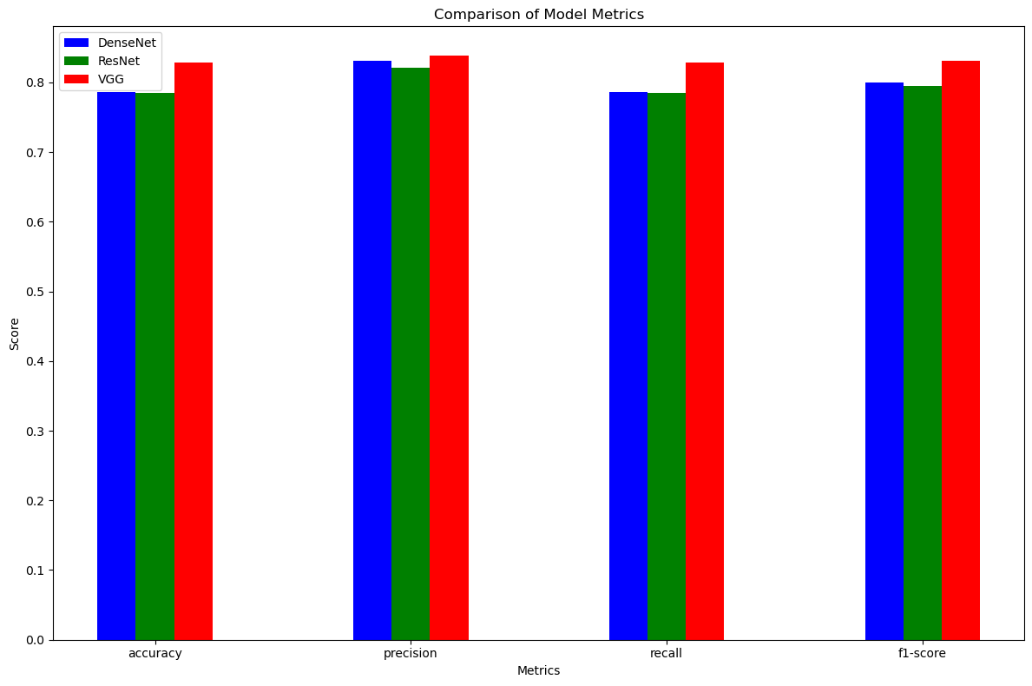

Figure (32) Models Metrics Comparison 3.0

And from Experiment 3.0 confusion matrices, we see a well-trained model, with balanced scores in all the six classes.

Based on the findings from Experiments 1.0, 2.0, and 3.0, this research underscores the critical importance of data quality, diversity, and appropriate model selection for optimal performance in skin condition classification. Experiment 1.0 highlighted the challenges faced by DenseNet due to data quality issues, resulting in poor generalization despite hyperparameter tuning. In Experiment 2.0, improvements in data handling and model architecture led to better performance metrics, demonstrating the value of deeper architectures and feature reuse. However, Experiment 3.0 revealed that for simpler subsets of the dataset, shallower models like VGG-19 achieved better and more balanced performance across all classes, suggesting that overly complex models can lead to overfitting on simpler tasks. This progression of experiments illustrates that matching the model complexity to the dataset is crucial for achieving robust and generalizable results in skin assessment applications.

# **Chapter 8 – Conclusion**

**8.1 Summary**

In conclusion, this project aimed to address the limitations of conventional skin condition diagnosis methods by developing an efficient model integrated into a mobile application. The primary objectives were to create a reliable and accessible alternative for individuals seeking quick and accurate skin condition assessments. Through the implementation of Convolutional Neural Networks (CNN), our model successfully diagnoses various skin conditions, including various skin diseases and bug bites, providing users with a convenient and user-friendly mobile application.

The project's contributions include building a diverse dataset that targets various skin conditions, the development of a robust and well-trained model, ensuring accurate and precise assessments. And creating a user-friendly application to enhance accessibility, enabling individuals without access to dermatologists or those with time constraints to receive reliable insights into their skin conditions. Early detection capabilities, particularly in the case of serious conditions like skin cancer and some bug bites, have the potential to improve overall patient outcomes.

**8.2 Limitations**

However, the project faced certain limitations and obstacles. One notable limitation is related to the quantity and type of data used. While the datasets employed in this project were diverse and encompassed various skin issues, there may be room for improvement in terms of dataset size and representation. Additionally, challenges in data preprocessing, such as handling imbalanced classes and ensuring uniformity their sizes, were encountered. Addressing these limitations could further enhance the model's performance and applicability.

**8.3 Future work**

For future work, it is recommended to explore the following avenues:

**1. Data Enhancement:** Increase the dataset size and diversity to improve the model's generalization capabilities. Expanding the problems targeted and considering incorporating more diverse images to account for various skin types and conditions.

**2. Model Optimization:** Explore advanced techniques for model optimization, including fine-tuning hyperparameters like GridsearchCV exploring different optimizers and loss functions, experimenting with different neural network architectures eg. (ResNext, etc.).

**3. User Feedback Integration:** Incorporate user feedback to continuously improve the application's performance and address specific user needs.

**4. Collaboration:** Collaborate with healthcare professionals to validate the model's accuracy and reliability in real-world clinical settings.

**5. Advanced Technique:** The use of advanced techniques such as segmenting the location of the disease in the image, the use of specified disease location to help get a better assessment.

## **Data Availability Statement**

Datasets that were modified and used in this project are publicly available. These datasets can be found in the references.

# **REFERENCES**

1. Yousef, H., Alhajj, M. and Sharma, S. (2020). *Anatomy, Skin (Integument), Epidermis*. National Center for Biotechnology Information. Available at: <https://www.ncbi.nlm.nih.gov/books/NBK470464/#:~:text=Skin%20is%20the%20largest%20organ>.
2. Kong, Y., Xing, P., Pengcheng Huai and Zhang, F. (2024). The burden of skin diseases in China: global burden of Disease Study 2019. Archives of dermatological research, 316(6). Doi: https://doi.org/10.1007/s00403-024-03046-5.
3. Ersavas, T., Smith, M.A. and Mattick, J.S. (2024). Novel applications of Convolutional Neural Networks in the age of Transformers. *Scientific Reports*, 14(1), p.10000. Doi: <https://doi.org/10.1038/s41598-024-60709-z>.
4. Agency, D. (2021). How to develop a user-friendly app | DECODE. [online] decode. Agency. Available at: <https://decode.agency/article/user-friendly-app/>.
5. ALKolifi ALEnezi, N.S. (2019). A Method of Skin Disease Detection Using Image Processing and Machine Learning. Procedia Computer Science, 163, pp.85–92. doi: <https://doi.org/10.1016/j.procs.2019.12.090>.
6. Mieras, L.F., Taal, A.T., Post, E.B., Ndeve, A.G.Z. and Van Hees, C.L.M. (2018b). The Development of a Mobile Application to Support Peripheral Health Workers to Diagnose and Treat People with Skin Diseases in Resource-Poor Settings, 3(3), p.102. Doi: <https://doi.org/10.3390/tropicalmed3030102>.
7. Tschandl, P., Codella, N., Akay, B.N., Argenziano, G., Braun, R.P., Cabo, H., Gutman, D., Halpern, A., Helba, B., Hofmann-Wellenhof, R. and Lallas, A., 2019. Comparison of the accuracy of human readers versus machine-learning algorithms for pigmented skin lesion classification: an open, web-based, international, diagnostic study. The lancet oncology, 20(7), pp.938-947.
8. Li, J., Cai, T., Deng, K., Wang, X., Sellis, T. and Xia, F., 2020. Community-diversified influence maximization in social networks. Information Systems, 92, p.101522.
9. Wang, L., Zhang, X., Wang, R., Yan, C., Kou, H. and Qi, L., 2020. Diversified service recommendation with high accuracy and efficiency. Knowledge-Based Systems, 204, p.106196.
10. Medical News Today. (2018). *Skin: Structure and Function Explained*. Available at: [https://www.medicalnewstoday.com/articles/320435#functions](https://www.medicalnewstoday.com/articles/320435%23functions).
11. World Health Organization. (2018). *Recognizing Neglected Skin Diseases: WHO Publishes Pictorial Training Guide*. Available at: <https://www.who.int/news/item/08-06-2018-recognizing-neglected-skin-diseases-who-publishes-pictorial-training-guide>.
12. Benedetti, J. (2021). *Diagnosis of Skin Disorders - Skin Disorders*. MSD Manuals. Available at: <https://www.msdmanuals.com/home/skin-disorders/biology-of-the-skin/diagnosis-of-skin-disorders>.
13. The Skin Cancer Foundation. (2019). *Self-Exams - The Skin Cancer Foundation*. Available at: <https://www.skincancer.org/early-detection/self-exams/>.
14. harkiran78 (2020). *Artificial Neural Networks and Its Applications*. GeeksforGeeks. Available at: <https://www.geeksforgeeks.org/artificial-neural-networks-and-its-applications/>.
15. Memon, M. (2022). *ANN vs CNN vs RNN: Neural Networks Guide*. levity.ai. Available at: [https://levity.ai/blog/neural-networks-cnn-ann-rnn#:~:text=Remember%3A](https://levity.ai/blog/neural-networks-cnn-ann-rnn%23:~:text=Remember%3A).
16. Singhal, S. (2021). *Skin Disease Classification*. Kaggle. Available at: <https://www.kaggle.com/code/smitisinghal/skin-disease-classification/notebook>.
17. Ilijoski, B, Trojachanec Dineva, K, Tojtovska Ribarski, B, Petrov, P, Mladenovska, T, Trajanoska, M, Gjorshoska, I, & Lameski, P 2023, 'Deep Learning Methods for Bug Bite Classification: An End-to-End System', Applied Sciences, vol. 13, no. 8, p. 5187, <https://doi.org/10.3390/app13085187>
18. VisualDx. (2018). *VisualDx Launches Aysa for Consumers to Check Skin Conditions Using AI*. Available at: <https://www.visualdx.com/blog/visualdx-launches-aysa-for-consumers-to-check-skin-conditions-using-ai/>.
19. Elbahnasy, K. (2023). *Skin Detection acc=98%*. kaggle.com. Available at: https://www.kaggle.com/code/khaledelbhnasy/skin-detection-acc-98.
20. aditikesarwani (2022). *skin_disease_detection*. Kaggle.com. Available at: https://www.kaggle.com/code/aditikesarwani/skin-disease-detection.
21. Bajwa, M. (2020). Computer-Aided Diagnosis of Skin Diseases usingDeep Neural Networks. [online] https://www.researchgate.net/. Available at: https://www.researchgate.net/publication/340459182_Computer-Aided_Diagnosis_of_Skin_Diseases_Using_Deep_Neural_Networks.
22. Patel, M. (2023). *The Complete Guide to Image Preprocessing Techniques in Python*. Medium. Available at: [https://medium.com/@maahip1304/the-complete-guide-to-image-preprocessing-techniques-in-python-dca30804550c](https://medium.com/@maahip1304/the-complete-guide-to-image-preprocessing-techniques-in-python-dca30804550c%20).
23. Spiceworks. (n.d.). *Pattern Recognition Working, Types, and Applications | Spiceworks*. Available at: <https://www.spiceworks.com/tech/artificial-intelligence/articles/what-is-pattern-recognition/>.
24. Sivarajah, U., Kamal, M.M., Irani, Z. and Weerakkody, V. (2017). Critical analysis of Big Data challenges and analytical methods. *Journal of Business Research*, 70(1), pp.263–286. Available at: <https://www.sciencedirect.com/science/article/pii/S014829631630488X.>
25. Chan, S., Reddy, V., Myers, B., Thibodeaux, Q., Brownstone, N. and Liao, W. (2020). Machine Learning in Dermatology: Current Applications, Opportunities, and Limitations. *Dermatology and Therapy*, 10(3), pp.365–386. doi: <https://doi.org/10.1007/s13555-020-00372-0.>
26. machine-learning-with-python.readthedocs.io. (n.d.). *Python Machine Learning Notebooks (Tutorial style) — Machine-Learning-with-Python documentation*. [online] Available at: <https://machine-learning-with-python.readthedocs.io/en/latest/>.
27. Cleveland Clinic. “Skin Diseases: Types Of, Symptoms, Treatment & Prevention. *Cleveland Clinic*, 2022, my.clevelandclinic.org/health/diseases/21573-skin-diseases. Available at: https://my.clevelandclinic.org/health/diseases/21573-skin-diseases
28. VENKAT DODDI, GUNA. “Eye_diseases_classification.” Www.kaggle.com, Available at: [www.kaggle.com/datasets/gunavenkatdoddi/eye-diseases-classification](http://www.kaggle.com/datasets/gunavenkatdoddi/eye-diseases-classification).
29. Mayo Clinic. “Cellulitis - Symptoms and Causes.” *Mayo Clinic*, 6 Feb. 2020, , Available at: [www.mayoclinic.org/diseases-conditions/cellulitis/symptoms-causes/syc-20370762](http://www.mayoclinic.org/diseases-conditions/cellulitis/symptoms-causes/syc-20370762).
30. Brind’Amour, Katherine. “Skin Disorders: Pictures, Causes, Symptoms, Treatments, and Prevention.” *Healthline*, 2014, www.healthline.com/health/skin-disorders,Available at: https://www.healthline.com/health/skin-disorders
31. Debelee, Taye Girma. “Skin Lesion Classification and Detection Using Machine Learning Techniques: A Systematic Review.” *Diagnostics (Basel, Switzerland)*, vol. 13, no. 19, 7 Oct. 2023, p. 3147, pubmed.ncbi.nlm.nih.gov/37835889/, Available at: <https://doi.org/10.3390/diagnostics13193147>.
32. FutureLearn. “What Is AI in Healthcare? Pros, Cons & Applications.” *FutureLearn*, 2 May 2023, Available at: www.futurelearn.com/info/blog/what-is-ai-in-healthcare.
33. Alzubaidi, L., Zhang, J., Humaidi, A.J., Al-Dujaili, A., Duan, Y., Al-Shamma, O., Santamaría, J., Fadhel, M.A., Al-Amidie, M. and Farhan, L. (2021). Review of Deep learning: concepts, CNN architectures, challenges, applications, Future Directions. *Journal of Big Data*, 8(1). doi: https://doi.org/10.1186/s40537-021-00444-8.
34. Sigari, S. (2023). *Striking the Balance between Data Quality and Quantity in Machine Learning*. Medium. Available at: <https://medium.com/@sigari.salman/striking-the-balance-between-data-quality-and-quantity-in-machine-learning-1f935a89f59b>.
35. Çanakçı, G. (2023). *Choose the Deep Learning Frameworks: A Comprehensive Guide*. Medium. Available at: https://medium.com/@gurkanc/choose-the-deep-learning-frameworks-a-comprehensive-guide-66553788730d [Accessed 24 May 2024].
36. Hosna, A., Merry, E., Gyalmo, J., Alom, Z., Aung, Z. and Azim, M.A. (2022). Transfer learning: a Friendly Introduction. *Journal of Big Data*, 9(1). doi: https://doi.org/10.1186/s40537-022-00652-w.
37. Simonyan, K. and Zisserman, A. (2015). *Published as a Conference Paper at ICLR 2015 VERY DEEP CONVOLUTIONAL NETWORKS FOR LARGE-SCALE IMAGE RECOGNITION*. Available at: https://arxiv.org/pdf/1409.1556.
38. He, K., Zhang, X., Ren, S. and Sun, J. (2015). *Deep Residual Learning for Image Recognition*. Available at: <https://arxiv.org/pdf/1512.03385>.
39. Huang, G., Liu, Z., Van Der Maaten, L. and Weinberger, K. (2017). *Densely Connected Convolutional Networks*. [online] Available at: https://openaccess.thecvf.com/content_cvpr_2017/papers/Huang_Densely_Connected_Convolutional_CVPR_2017_paper.pdf.
40. Beheshti, N. (2022). *Guide to Confusion Matrices & Classification Performance Metrics*. Medium. Available at: https://towardsdatascience.com/guide-to-confusion-matrices-classification-performance-metrics-a0ebfc08408e [Accessed 30 Jun. 2022].
41. DermNet NZ. DermNet Skin Disease Atlas. Available from: <https://dermnetnz.org/>. Licensed under CC BY-NC-ND 4.0.
42. bug bites Dataset. (2024). [ Open-Source Dataset]. In Roboflow Universe. Roboflow. %20https://universe.roboflow.com/object-detection-ttfpu/bug-bites%20
43. Shafi, S. and Assad, A. (2023). Exploring the Relationship Between Learning Rate, Batch Size, and Epochs in Deep Learning: An Experimental Study. *Lecture notes in networks and systems*, pp.201–209. doi:https://doi.org/10.1007/978-981-19-6525-8_16.
44. Ali, S. (2024). *Introduction to convolutional neural networks (CNN)*. [online] Educative. Available at: https://www.educative.io/blog/introduction-to-convolutional-neural-networks.

# **APPENDICES**